Technical Specification
PURE-XML
Parliament Unique Repository
for XML text production

Approval
Name | Role  MOA/MOE | Date  Approval | Approval  Y/N | Address  DG or Company
Olivier Leboeuf | MOA-Sponsor |  |  | ITEC
CIRCULATION
Name -Telephone number |  | DG or Company | ERICA code
Olivier Leboeuf |  | DG ITEC | AC
Felicity Hands |  | DG ITEC | AC
Claudio Fabiani |  | DG ITEC | AC
Olivier Fabbri |  | DG ITEC | AC
Gianluigi Alari |  | DG ITEC | AC
Jesus Cerro |  | DG ITEC | AC
Updates
Version | Date | Sections changed | Description | Author(s)
0.1 | 17/02/2012 | All | Initial draft | PPA, NBE
0.2 | 07/03/2012 | All | Update and reply on comments | NBE, PPA, MBA, GAL
0.3 | 16/03/2012 | All | Minor updates based on onsite workshop discussions | NBE, PPA, MBA, CTR
1.0 | 06/04/2012 | All | Added major updates based on onsite workshop discussions | NBE, PPA, MBA, CTR
1.1 | 03/05/2012 | All | Addressed minor comments, reorganised content | PPA, MBA, CTR
1.2 | 14/05/2012 | All | Updated document according to latest Functional Specifications | PPA, MBA, CTR
1.3 | 17/05/2012 | 1.3.1  2.2.2.3.1  6.1.1.12  9.1.1.14 | - Updated reference to functional specifications  - Added clarifications for the implementation of the links  - Removed references to LINK_TYPES table.  - Updated use case "Move Folder" and removed step "Update Parent URI properties" must be removed | PPA, MBA, CTR
1.4 | 08/01/2013 | All | Updated with the latest implementation details | PPA
1.5 | 08/05/2013 | 2.1.2.1.4  2.1.5.1  3.1 | - Updated message body example (groups tag)  - Updated parent folder URI and User group property names and description. Added impacted and related object UBI properties.  - Added packages eu.europa.europarl.purexml.annotation, eu.europa.europarl.purexml.enumeration | PPA
1.6 | 01/07/2013 | 2.1.2.1.4 | JMS message properties added | PPA
1.7 | 03/09/2013 | Annex I | Updated error codes | PPA
1.8 | 09/12/2013 | All | Implementation updates | PPA, DBA
1.9 | 08/01/2014 | Annex I | Updated error codes | PPA
Table of COntent
1. General Introduction 7
1.1. Purpose 7
1.2. Usage conventions 7
1.3. Applicable and Reference Documents 7
1.3.1. Applicable Documents 7
1.3.2. Reference Documents 7
1.4. Glossary 7
2. Overall technical architecture 9
2.1. Technical architecture chart 9
2.1.1. Design considerations 9
2.1.2. System architecture overview 9
2.1.3. Hardware requirements 29
2.1.4. Software requirements 29
2.1.5. Installation 30
2.1.6. Configuration 31
2.1.7. Quality control requirements 31
2.1.8. Testing requirements 32
2.2. Description of database model 32
2.2.1. Data dictionary 33
3. Software Architecture 39
3.1. Static view 39
3.2. Non-functional constraints 48
3.2.1. Post-incident restart 48
3.2.2. Backup-Restoration 49
3.2.3. High availability 49
3.2.4. Security constraints 51
3.3. Associated unit tests 53
4. Annex I: Application Error Codes 54
5. Annex II: Software Requirements Details 58
6. Annex III: Data Structure Details 59
6.1. Table BINARY_RENDITION 60
6.1.1. Card of table BINARY_RENDITION 60
6.1.2. List of columns of the table BINARY_RENDITION 60
6.1.3. List of indexes of the table BINARY_RENDITION 60
6.1.4. List of outgoing references of the table BINARY_RENDITION 60
6.2. Table CHANGELOG_EVENT 61
6.2.1. Card of table CHANGELOG_EVENT 61
6.2.2. List of columns of the table CHANGELOG_EVENT 61
6.2.3. List of indexes of the table CHANGELOG_EVENT 62
6.3. Table CONTENT_TYPE 63
6.3.1. Card of table CONTENT_TYPE 63
6.3.2. List of columns of the table CONTENT_TYPE 63
6.3.3. List of indexes of the table CONTENT_TYPE 63
6.3.4. List of incoming references of the table CONTENT_TYPE 63
6.4. Table CONTENT_TYPE_PROPERTY 64
6.4.1. Card of table CONTENT_TYPE_PROPERTY 64
6.4.2. List of columns of the table CONTENT_TYPE_PROPERTY 64
6.4.3. List of indexes of the table CONTENT_TYPE_PROPERTY 64
6.4.4. List of incoming references of the table CONTENT_TYPE_PROPERTY 64
6.4.5. List of outgoing references of the table CONTENT_TYPE_PROPERTY 64
6.5. Table DB_VERSIONS 65
6.5.1. Card of table DB_VERSIONS 65
6.5.2. List of columns of the table DB_VERSIONS 65
6.6. Table EP_GROUP 65
6.6.1. Card of table EP_GROUP 65
6.6.2. List of columns of the table EP_GROUP 65
6.6.3. List of incoming references of the table EP_GROUP 65
6.7. Table MEDIA 66
6.7.1. Card of table MEDIA 66
6.7.2. List of columns of the table MEDIA 66
6.7.3. List of indexes of the table MEDIA 66
6.7.4. List of outgoing references of the table MEDIA 66
6.8. Table NOTIFICATION_PROPERTY 66
6.8.1. Card of table NOTIFICATION_PROPERTY 66
6.8.2. List of columns of the table NOTIFICATION_PROPERTY 66
6.9. Table RELATIONSHIP 67
6.9.1. Card of table RELATIONSHIP 67
6.9.2. List of columns of the table RELATIONSHIP 67
6.9.3. List of incoming references of the table RELATIONSHIP 67
6.10. Table RELATIONSHIP_ALLOWED_TYPE 68
6.10.1. Card of table RELATIONSHIP_ALLOWED_TYPE 68
6.10.2. List of columns of the table RELATIONSHIP_ALLOWED_TYPE 68
6.10.3. List of indexes of the table RELATIONSHIP_ALLOWED_TYPE 68
6.10.4. List of outgoing references of the table RELATIONSHIP_ALLOWED_TYPE 68
6.11. Table REPOSITORY_OBJECT 69
6.11.1. Card of table REPOSITORY_OBJECT 69
6.11.2. List of columns of the table REPOSITORY_OBJECT 69
6.11.3. List of indexes of the table REPOSITORY_OBJECT 70
6.11.4. List of incoming references of the table REPOSITORY_OBJECT 70
6.11.5. List of outgoing references of the table REPOSITORY_OBJECT 71
6.12. Table REPOSITORY_OBJECT_ACE 72
6.12.1. Card of table REPOSITORY_OBJECT_ACE 72
6.12.2. List of columns of the table REPOSITORY_OBJECT_ACE 72
6.12.3. List of indexes of the table REPOSITORY_OBJECT_ACE 72
6.12.4. List of outgoing references of the table REPOSITORY_OBJECT_ACE 72
6.13. Table REPOSITORY_OBJECT_LINK 73
6.13.1. Card of table REPOSITORY_OBJECT_LINK 73
6.13.2. List of columns of the table REPOSITORY_OBJECT_LINK 73
6.13.3. List of indexes of the table REPOSITORY_OBJECT_LINK 73
6.13.4. List of outgoing references of the table REPOSITORY_OBJECT_LINK 73
6.14. Table REPOSITORY_OBJECT_PROPERTY 74
6.14.1. Card of table REPOSITORY_OBJECT_PROPERTY 74
6.14.2. List of columns of the table REPOSITORY_OBJECT_PROPERTY 74
6.14.3. List of indexes of the table REPOSITORY_OBJECT_PROPERTY 74
6.14.4. List of outgoing references of the table REPOSITORY_OBJECT_PROPERTY 74
6.15. Table REPOSITORY_OBJECT_PWC 75
6.15.1. Card of table REPOSITORY_OBJECT_PWC 75
6.15.2. List of columns of the table REPOSITORY_OBJECT_PWC 75
6.15.3. List of indexes of the table REPOSITORY_OBJECT_PWC 75
6.16. Table REPOSITORY_OBJECT_RELATIONSHIP 76
6.16.1. Card of table REPOSITORY_OBJECT_RELATIONSHIP 76
6.16.2. List of columns of the table REPOSITORY_OBJECT_RELATIONSHIP 76
6.16.3. List of indexes of the table REPOSITORY_OBJECT_RELATIONSHIP 76
6.16.4. List of outgoing references of the table REPOSITORY_OBJECT_RELATIONSHIP 76
6.17. Table REPOSITORY_OBJECT_TAG 78
6.17.1. Card of table REPOSITORY_OBJECT_TAG 78
6.17.2. List of columns of the table REPOSITORY_OBJECT_TAG 78
6.17.3. List of indexes of the table REPOSITORY_OBJECT_TAG 78
6.17.4. List of outgoing references of the table REPOSITORY_OBJECT_TAG 78
6.18. Table TAG 79
6.18.1. Card of table TAG 79
6.18.2. List of columns of the table TAG 79
6.18.3. List of indexes of the table TAG 79
6.18.4. List of incoming references of the table TAG 79
6.19. Table XML_METADATA 80
6.19.1. Card of table XML_METADATA 80
6.19.2. List of columns of the table XML_METADATA 80
6.19.3. List of indexes of the table XML_METADATA 80
6.19.4. List of outgoing references of the table XML_METADATA 80
6.20. Table XML_RENDITION 81
6.20.1. Card of table XML_RENDITION 81
6.20.2. List of columns of the table XML_RENDITION 81
6.20.3. List of indexes of the table XML_RENDITION 81
6.20.4. List of outgoing references of the table XML_RENDITION 81
6.21. View REPOSITORY_OBJECT_SEARCH_MV 81
6.21.1. Card of the view REPOSITORY_OBJECT_SEARCH_MV 81
6.21.2. List of view columns of the view REPOSITORY_OBJECT_SEARCH_MV 82
6.21.3. List of view indexes of the view REPOSITORY_OBJECT_SEARCH_MV 82
6.22. View STATISTICS_MV 84
6.22.1. Card of the view STATISTICS_MV 84
6.22.2. List of view columns of the view STATISTICS_MV 84
7. Annex IV: Class Diagrams 87
8. Annex V: Performance Comparison of Storage Technologies 88
9. Annex VI: Performance impact for future development 91
10. Annex VII: Activity Diagrams 92
10.1.1. Create Node 92

General Introduction

Purpose
The purpose of this document is to provide as accurate a description as possible of the technical characteristics of a product or system in line with the wishes expressed by the sponsor/project owner/client.
The overall description of the project is described in previous documents, e.g. 'Project Charter'.
Caution: Conceivably, either a comprehensive document covering all functions or a technical document for each function could be drawn up.

Usage conventions
The parts in yellow indicate the area where information should be entered, and must remain in yellow to highlight information connected with the project.
Where a chapter or section is not considered to be applicable, put ‘NOT APPLICABLE’.
Click on the Show/Hide button in the toolbar to display/hide guidance on filling in this document.
Guidance displayed.

Applicable and Reference Documents
This chapter sets out the reference documents on which this guide is based.

Applicable Documents
This section details the applicable documents used in drafting this document. The applicable documents are standards, specimen plans which need to be applied and whose application is verifiable.
N° | Title | Remarks
[1] | PURE-XML_Functional_Specification_v1-14.doc | Functional specifications
[2] | PURE-XML_MIN_20120131_EN_v1.1-approved | Kick off meeting minutes
[3] | Pure-XML_Javadoc_3_5_3.zip | PURE-XML Javadoc

Reference Documents
This section details the reference documents used in drafting this document. Reference documents help in defining the project but are not directly applicable (e.g. software reference manuals, sample files from outside firms, meeting papers).
N° | Title | Remarks
[1] | Annex 4 – PURE-XML sizing | PURE-XML sizing
[2]
[3]

Glossary
The glossary is available at ICTASnet : - Zone 'Vos indispensables'-Glossaire.
Abbreviation | Description

Overall technical architecture
This section sets out the technical architecture to be introduced.

Technical architecture chart

Design considerations

PURE-XML exposes an API on top of a content repository engine which is based on the PURE-XML content model. The functionalities provided by PURE-XML is though the API that will be utilized by intranet modules (clients). The architecture of PURE-XML is influenced by the Domain Driven Design and the design of the software artifacts rely on the domain model.
The major design consideration is performance. Other main design considerations are:
- Robustness under stress tests
- Modularity
- Fault-tolerant and fast recovery
- Extendable and capable to adopt changes
- Standard APIs
- Maintainability (e.g. library updates)

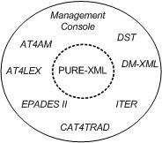
Figure 1: PURE-XML High Level Schema

System architecture overview

Implementation view

The implementation view of PURE-XML is depicted in the following diagram:

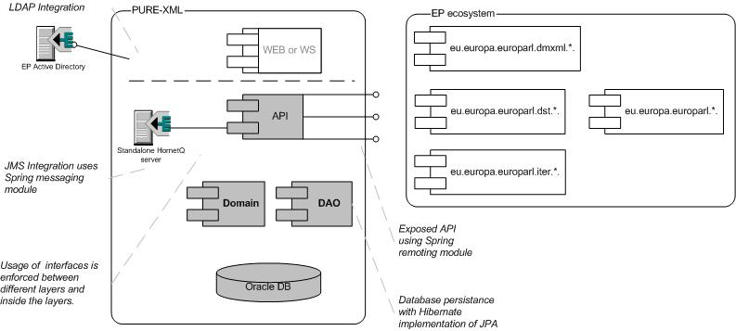
Figure 2: PURE-XML Architecture

Database

This section details the comparison of available storage technologies that led to the selection of Oracle XML DB.

Oracle provides the following storage options for XMLType:
  - CLOB storage
  - Object relational store (OR)
  - Binary storage

XMLType with CLOB storage and Object relational store show poor performance compared to the binary storage options and plain CLOB, so they are discarded.

On the other hand, the object relational store option enforces very strict rules on how the XML schema should be defined, tuned and optimised, in order to avoid proliferation of automatically created system tables. Taking into consideration the variety of XMLs that is stored in the PURE XML system this option is rejected.

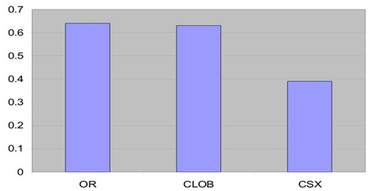
Figure 2: Full document retrieval time

Consequently, the candidate storage options for XML data are the XMLType, stored as binary and the plain CLOB option.

Oracle Binary XML format

Binary storage is the new storage model in Oracle 11g database and it offers a couple of possibilities that can be used in the context of the PURE-XML project. Oracle Binary XML is designed to support the entire lifecycle of applications that make heavy use of XML. It supports DDL, DML, query (SQL/X and XQuery), partitioning, XML indexing, importing/exporting, expedite data loading.

The Oracle Binary XML format is designed to be compact and efficient for a wide variety of operations including streaming XPath evaluation, fragment extraction, node-level updates, conversion to/from XML 1.0/1.1 (text) as well as building a DOM.

The Oracle database implementation for a binary XML document is a BLOB column, thus allowing binary XML documents to leverage Oracle SecureFiles LOB features such as encryption, de-duplication, compression and piecewise update.

The binary XML format can be considered as a serialized set of SAX operation codes that are persisted in a logically sequential form. In addition, the format has the following properties:
- Allows mixing of data and metadata to provide schema flexibility
- Is transferable as a document or file over standard protocols by fitting into IETF MIME type conventions. This enables Oracle mid-tiers and other parties to handle the format directly without converting back-and-forth to XML in text form
- Attempts to provide relational performance and functionality by approaching a relational row format for very structured schemas. The binary XML storage option takes advantage of XML schemas, if available, to store a highly compacted XML using Oracle data types such as numbers and dates. This has the added advantage of faster processing by saving on data conversion costs
- Provides a mechanism of locators that serve as node identifiers and can be used to start processing from an arbitrary point. This forms the basis of XML indexing and streaming evaluation for xpaths.

The following PURE-XML requirements and constraints can be addressed by using XMLType with binary storage:
- Piecewise update: Binary XML format allows piecewise updates by storing only the changed portions to disk. This means that only data that is changed is overwritten. This feature is provided by Oracle Secure Files and reduces the I/O bandwidth utilisation significantly. Furthermore, the XMLIndex is also made aware of the exact changed portions whereby only those rows in the XML index that are related to the affected portions are updated. This feature is used to implement efficiently the “Update XML content” function.

- Indexation of XML metadata using XPath: the binary XML storage would typically be used in conjunction with an XML index for speeding up query access. As stated above, XMLIndexes are aware of exact changed portions, so only affected rows in the index is updated. Update is done online. This feature provides the recommended database implementation for allowing the XML metadata to be searched, restricting the search scope with XPath expressions.

- Binary storage supports schema evolution and allows storage for XMLs not having strict schema. This addresses the requirement that documents to be handled by PURE-XML may or may not abide to specific XSD/DTD schemas.

A performance comparison of XML with binary storage against CLOB is presented in Annex V: Performance Comparison of Storage Technologies. The overall conclusion is that XML with Binary storage outperforms CLOB and offers more flexibility.

Partitioning is not used due to the expected performance gain not justifying the imposed complexity overhead.

Domain/DAO

The set of entities that correspond to the content model are implemented as POJOs. These POJOs constitute the Domain tier.

The Data Access Object or Repository layer satisfies the needs of the business logic and is not part of the service tier, since it is an implementation detail.

The Persistence layer of PURE-XML is used to decouple the service tier from the data tier. It contains software components that map application entities to PURE-XML’s database and utilizes the Hibernate implementation of JPA. This application architecture offers advantages in terms of maintenance and evolution:
- The API does not change when the underlying database schema changes. The DAO layer is able to adopt data access scheme extensions without affecting to the API.
- Extensions to the application’s API affect the DAO layer in a lesser extent.

By using Hibernate implementation of JPA provider, the repository CRUD operations are implemented in the DAO layer. The JPA EntityManager is utilized to persist or retrieve the domain model entity objects. An example the DAO implementation is the following:

NodeEntity nodeEntity = entityManager.createQuery("select * from NODES where URI = ?1").setParameter(1, URI).getSingleResult();

Direct access to the database through the API is discarded as it constitutes a bad design practice. The DAO layer acts as an adapter between the API and the data source by hiding the database implementation details from the API and providing standard reusable database implementation. The interfaces exposed by the DAO layer to the API does not need to change when the underlying database implementation changes. This pattern allows the DAO to adapt to different storage schemes without affecting the business components. Moreover, due to the limited number of entities, the additional code required to implement the thin layer of DAO objects is not considered an overhead.
The domain model entities are grouped into functional components. For each functional component one or more DAOs are implemented. The DAO implementation details are documented in PURE-XML Javadoc (see ref. [3]).

Hibernate does not provide standard support for Oracle XMLType columns. XML document handling is implemented in the DAO layer.

An alternative architecture approach would be based on Spring Data. In this case, Spring Data JPA would provide support for JPA based data access. The DAO layer of PURE-XML that provides CRUD operations would be replaced by Spring Data repository interfaces. More specifically Spring provides CrudRepository that is typeable to the domain class to manage as well as the id type of the domain class and provides functionality around CRUD for the entity being managed. Repository interfaces would be created for domain entity classes. For example, for the NodeEntity class a repository interface would be created:

public interface NodeEntityRepository extends CrudRepository<NodeEntity, Long> { … }

The database queries would be constructed by the query method name by using Spring’s query builder mechanism, for example:

NodeEntity findByURI(String URI);

Another example for NodeEntityRepository is using declared queries:

@Query("select count(id) from NODES where URI = ?1")
Long countNodes(String URI);

Furthermore, Spring Data JDBC extension provides support for Oracle XMLType columns through OracleXmlHandler implementation class. OracleXmlHandler provides database specific implementations for handling storing and retrieving XML documents to and from fields in a database. An example of XML rendition creation is the following:

jdbcTemplate.update("INSERT INTO xml_rendition (id, content_type_id, content_data) VALUES (?, ?, ?)",
id, contentTypeId, sqlXmlHandler.newSqlXmlValue(xml));

Spring Data JDBC does not provide support for Oracle updateXML() function using a given XPath expression.

Although Spring Data is a promising technology, it is comparatively recent and thus has not been as widely deployed and tested as Hibernate/DAO.

Taking into account the PURE-XML requirements for high levels of stability, Hibernate/DAO is selected as a more secure option.

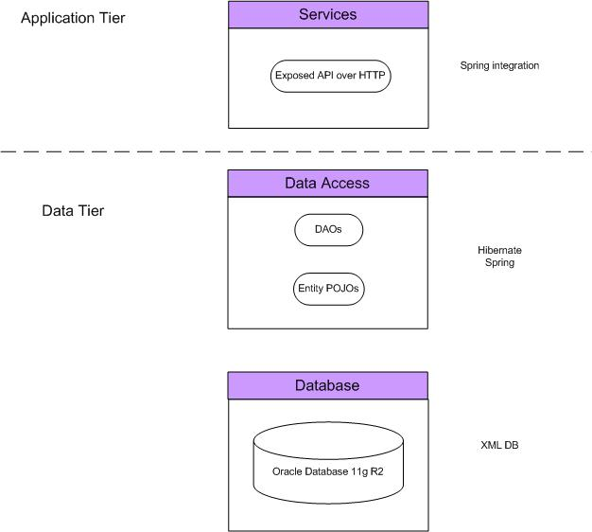
Figure 3: Application and Data tiers

- Service Tier: The Service tier exposes the remote-enabled API. The API uses Spring remoting technologies and encapsulates the business logic. The Spring container provides transaction management support, which manages the database transaction execution. Annotation driven transaction configuration (via @Transactional annotation) is used. Long lived transactions are managed on application level. Long lived transactions can be identified in the checkout and lock functions for the repository objects and are used to ensure the consistency of the repository objects. If a repository object is checked-out or locked by a user, no other user will be able to checkout or modify this object. A long lived transaction is committed when a user executes check-in or unlock functions. The rollback of long lived transactions is executed when cancel check-in function is executed.
- Data Tier: The Data tier of PURE-XML is implemented with Spring Beans designed around the Data Access Object (DAO) design pattern which decouples the data access from the higher application tiers. The DAO objects retrieve or persist entity beans, implemented as Plain Old Java Objects (POJOs). DAOs use the Hibernate object-relational mapping framework, in order to map entity POJOs with the relational database schema.

API
According to the EP standards, the exposed API is based on Spring remoting and correspond to the functional specifications. This layer comprises the implementation of the business rules that are derived from the PURE-XML content model (based on the IRO document model) and it supports the integration with the client applications

The Spring framework (Spring Remoting) provides the Spring HTTP Invoker which is used for exposing the API to external applications. In this case, both client (external application) and server (PURE-XML) must be implemented in Spring. Exposing services with Spring RMI is also an option since it supports clients with traditional RMI endpoints. Since the application is an intranet application both implementations perform equivalent, but the RMI approach cannot be implemented using the EP default infrastructure for high availability, as RMI communication is not handled by Apache Tomcat. Therefore a hardware load balancer should be used for high availability in this scenario.
The exposure of the PURE-XML API over HTTP fits better with reverse proxy configuration which exists already in EP. Proxy caching issues are prevented as Spring translates clients’ API calls to HTTP POST requests at the URL pointing to the exported service. The default implementation on the client side creates a standard PostMethod with "application/x-java-serialized-object" as "Content-Type" header without specifying Cache-Control or Expires header fields.

The Spring HTTP Invoker leverages HTTP, Java serialization and other standard facilities like Apache HttpClient. According to the EP standards, Spring HTTP Invoker remoting strategy is used in both ends to set up the communication of clients to PURE XML over HTTP.

Persistence and transaction management

PURE-XML uses Hibernate implementation of JPA for database persistence. The domain model entity classes use Hibernate annotation mappings. The annotations configuration provides the mapping between the domain model entities and the Oracle database objects. In this way, the data retrieval and persistence is executed by using the entities. The JPA EntityManager is used to persist or retrieve the domain model entity objects.

PURE-XML uses Spring’s transaction management abstraction. Every API method call executes all database statements in a single database transaction. PURE-XML uses Spring declarative transaction management. The API methods are annotated with @Transactional annotation. The transaction support is enabled via AOP proxy that uses a TransactionInterceptor with an appropriate PlatformTransactionManager implementation to drive transactions around method invocations. In this way the transaction begins and ends before and after the execution of the annotated method by using the around advice. In case an exception is thrown during the execution of the method, the transaction is rolled back, otherwise the transaction is committed. In this way, the database is in consistent state even in cases of failure. This process is depicted in the following diagram:

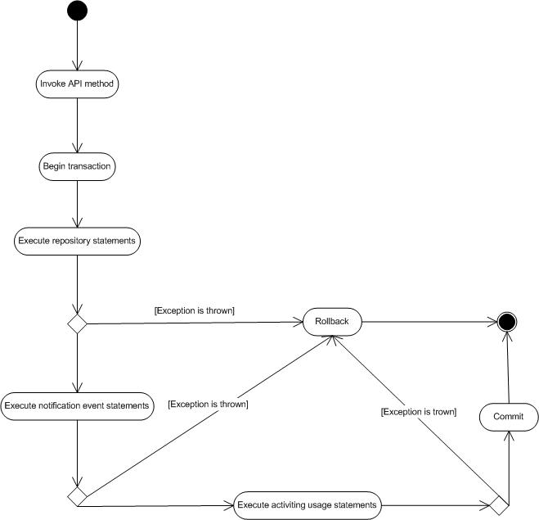

PURE-XML uses Spring AOP to intercept the API methods after the join point execution in order to perform notification event processing and activity usage logging. The notification event and activity database logging is executed in the same transaction with the intercepted method. The notification and activity usage aspects implement org.springframework.core. Ordered interface so that precedence of those aspects are set and the execution of the advices are ordered. The @Transactional annotation is configured with Ordered.LOWEST_PRECEDENCE order. This defines that the transaction advice is executed with the lowest precedence. The advices with the highest precedence is executed first when running on the same joint point. In this way those aspects are ordered and executed before the transaction around advice.

Distributed transaction management

PURE-XML handles distributed transactions across the messaging server and the database. Best efforts one-phase commit pattern is used for distributed transaction management.
The notification messages are retrieved from the database, published to the relevant JMS topics and finally updated as processed in the database. This process should be handled in an atomic way so that it either succeeds or fails as a complete unit and it’s depicted in the following diagram:

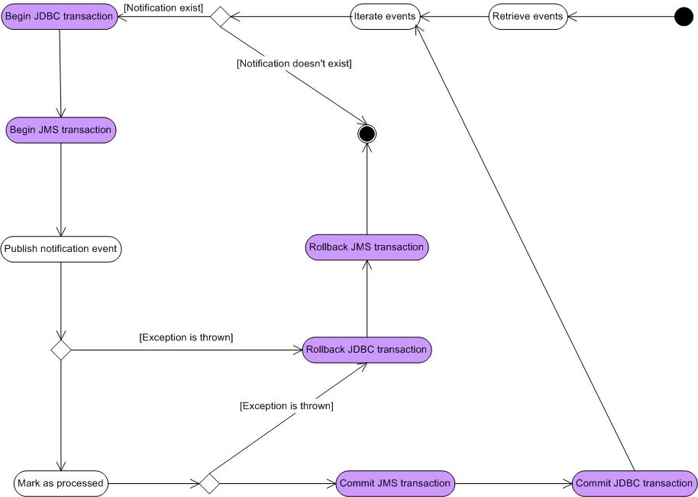

This process prevents from having notification messages that are not published to the JMS destinations. In case of an infrastructure failure while the system is performing commit/rollback of the JDBC transaction, the message is sent more than once to the HornetQ server. Spring programmatic transaction management is used for the implementation of the distributed transaction management.

Another option would be to use XA transactions with two-phase commit. This option is able to ensure the proper execution of the distributed transaction even in the case of a failover using the two-phase commit protocol. This option will provide additional performance overhead.

Taking into account that PURE-XML major design goal is performance, best efforts one-phase commit pattern is selected as the transaction management pattern used for distributed transactions.

Checkout and lock handling

PURE-XML avoids race conditions during the concurrent execution of checkout and lock functions.

When the checkout function is executed for a specific node, then if the copy-children parameter is true, the node and the node’s children is marked as checked-out by the user and then a copy of the node and the node’s children recursively is created and marked as PWC in the database. If the copy-children parameter is false, then only the specified node is marked as checked-out and a copy of this node is created as the PWC. When an object is marked as checked-out by a user, no other user is able to modify this node. This prevents from concurrent execution of actions from multiple users on the same object. When the node modifications are completed and the check-in or cancel check-in function is executed, the object is available for checkout by other users.

PURE-XML also provides a lock function for repository objects. By executing the lock function for an application defined list of nodes, the nodes are marked as locked and the users are not be able to checkout or modify these nodes.

Cross reference check-outs and dead lock situations are prevented through the design.

Oracle provides support for hierarchical queries. PURE-XML is able to retrieve the object’s hierarchy by using hierarchical queries against the repository objects. One example query that returns a list of an object’s children is the following:

SELECT *
FROM node
START WITH id = 100
CONNECT BY PRIOR id = parent_id

Another option for object hierarchy retrieval is to use the object’s ABSOLUTE_PATH. The object’s URI or the ABSOLUTE_PATH are not stored in the database but dynamically created via Oracle PL/SQL functions. The option of storing the URI in the database is able to introduce significant performance overhead for specific repository operations such as move, rename etc. During the execution of those functions, the system should perform bulk updates over the object’s hierarchy recursively. Additionally, the object’s URI may vary depending on the access path, the alias or the version identifiers having as a result multiple URIs to lead to the same object. For the above mentioned reasons the URIs are not stored in the database, but are dynamically created via PL/SQL functions.

PURE-XML combines hierarchical queries with the FOR UPDATE clause that lock the selected rows of this table until the transaction is committed or rolled back. This statement prevents from concurrent execution of object locking and checkout functions in the database level. With this design the API serializes the execution of concurrent calls by default.

The above locking mechanism consist the default repository business transaction mode. Additionally, the API provides facilities for user defined business transactions as a long-lasting locking mechanism. During the time of the start and end of the business transaction the node and the node’s children are locked and no other data manipulation functions can be executed over these nodes.

URI calculation and checkout functions are performed through Oracle PL/SQL procedures that handles the execution as described above.

Schedulers

PURE-XML handles the execution of scheduled processes. The quartz scheduler is triggered based on a cron expression and is configured using Spring CronTriggerBean.

The following schedulers are implemented:

Scheduler | Description
Notifications scheduler | Implements a scheduled execution that fires based on a cron expression and is used for the notifications retrieval and sending. The notification events are retrieved and addressed to the JMS destination based on the event creation date.
Clear repository transactions | Implements a scheduled execution that fires based on a cron expression and is used for the clean-up of the repository transactions. These transactions are business defined and are used for the serialization of execution of concurrent API calls. Any transactions that are not ended, they are automatically cleaned-up by this scheduler.
Statistics | Implements a scheduled execution that fires based on a cron expression and is used for refreshing the repository statistics. An Oracle materialized view is used on the database level. This design reduces the response times for repository statistics retrieval through the API. Additionally, is prevents the execution of heavy statistical queries against the database.
Search | Implements a scheduled execution that fires based on a cron expression and is used for refreshing the repository search indexes. Oracle Text indexes and materialized view is used on the database level. This design reduces the response times for repository search. Apart from the Oracle Text indexes, the Oracle materialized view is explicitly indexed for increasing the response times of the search queries. Search criteria, such as the URI, are pre-calculated in the materialized view and so heavy hierarchical queries are prevented during the execution of search.

Error handling

The PURE-XML throws business and system exceptions via its Java API. The error codes and messages for the repository exceptions are defined in Annex I.

The Spring DAO support provides exception translation from the data tier to the service tier using its own exception class hierarchy with the DataAccessException as the root exception class. Those exceptions consists a set of unchecked exceptions that will be propagated to the higher architectural levels of the application.

The service layer throws custom system and business exceptions. The exceptions contain an error code defining the exact cause of the error. The service layer provides support for the translation of unchecked exceptions. An after throwing AOP advice implements the exception translation by wrapping the unchecked exceptions that are thrown during runtime and re-throw custom exceptions with application defined error codes.

Messaging

HornetQ is deployed as a stand-alone server, in order to isolate the application server from the messaging server. The PURE-XML application utilizes Spring messaging module (org.springframework.jms package) to integrate with HornetQ. Spring provides support for message production and consumption through a simplified use of the JMS API. PURE-XML uses JNDI lookups to obtain access to queues, topics and ConnectionFactory instances. The ConnectionFactory is used to create JMS connections, which can then be used for sending and receiving messages. Spring's CachingConnectionFactory is used for caching the JMS objects such as the connection, the session and the producer in order to be re-used while sending the messages to the destinations. Destination objects, which represent topics and queues in JMS, are also obtained via JNDI. Message production process is depicted in the following diagram:

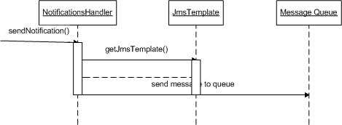
Figure 7: PURE-XML Message production sequence diagram

Whenever a repository object event occurs, an event object is instantiated, persisted in the relevant event table in the database and flagged as not sent for notification (table column IS_PROCESSED). A quartz scheduler that is executed periodically retrieves from the database all the events that are flagged as not sent for notification and address them to the JMS destinations. The quartz scheduler is triggered based on a cron expression that is configured using Spring CronTriggerBean.

The notification events are retrieved from the database, ordered by creation date and are sent sequentially to the topic destinations. In this way, the notification events are sent to the topics based on the event creation date. Each time a notification message is sent to a topic, the reception of the message by the HornetQ server should be ensured before sending the next message. PURE-XML uses transacted sessions for message publishing. Messages delivered by the HornetQ server in a transaction are not forwarded to the subscribers until the transaction is committed by the publisher. When the commit or rollback is received on the HornetQ server, it is committed to the journal and the server ensures that the commit or rollback is durably persisted to storage. After sending a message to the HornetQ server, the notification event is marked as processed and the JMS transaction is committed. If an error occurs during this process both JMS and database transactions is rolled back and the scheduled process ends. In this way we ensure the ordered delivery of the message to the HornetQ server.

The event message creation process is depicted in the following diagram:

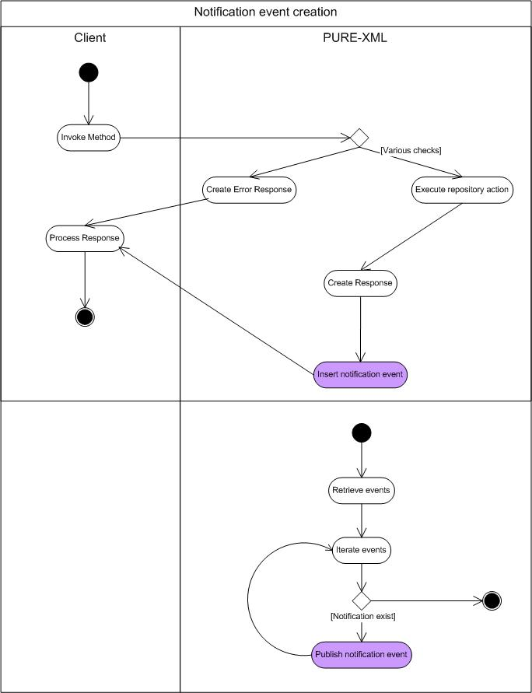
Figure 8: PURE-XML Event creation activity diagram

The diagram activities are continued through asynchronous process in section.10.1.1.53.

Topics

The notification mechanism allows the client applications to retrieve notifications related to repository object events. PURE-XML publishes event messages on topics. The client applications are able to subscribe to a topic and fetch a copy of each message queued in this topic. The client applications subscribe to a topic destination by using the topic name and a client identifier. The subscriptions of the client applications are durable in order to retain the subscription’s messages until they are consumed or expired. The client applications’ integration with the HornetQ server are implemented by using the Spring messaging module.

PURE-XML supports an external configuration mechanism for JMS destination management. The elements described in the configuration are the following:
- API function
- Object type
- Content type

The configuration entries are stored in the NOTIFICATION_PROPERTIES database table containing the following columns:

Name | Comment | Data Type | Mandatory | Primary | Foreign Key | Default Value
ID | System assigned ID. Populates from hornetq_properties_seq | NUMBER | X | X
API_FUNCTION | The API function | VARCHAR
OBJECT_TYPE | The object type name of the repository object | VARCHAR
CONTENT_TYPE | The content type of the repository object | VARCHAR
TOPIC_NAME | The name of the HornetQ server topic | VARCHAR
ENTRY_NAME | The entry name of the HornetQ server topic | VARCHAR

Each entry of this configuration mapping results to a destination. The configuration of the messaging server has to be done manually. In case the destination is not properly configured the message will be discarded.

HornetQ provides support for server configuration management through its management API. The creation of the topics and queues on the messaging server is done manually, using the server's configuration interface.

The “*” wildcard is supported for the definition of topics. An example of a configuration entry is the following:

ID | API_FUNCTION | OBJECT_TYPE | CONTENT_TYPE | TOPIC_NAME | ENTRY_NAME
1 | * | * | Amendments | Amendments | /topic/Amendments

The above topic definition entry generates a JMS topic containing all the messages that concern objects with the Content Type being “Amendments”.

Every generated event message is addressed to one or more topics based on the topic configuration mapping. Each notification message is related and addressed to a set of topics on the HornetQ server. The notification message attributes are matched to the configuration criteria for every generated message. If the message attributes match all configuration entry criteria, the message is addressed to the configuration entry’s topic.

The API function names will be the following:

Action | API function name | Description
node created | NODE_CREATED | Initial object creation.
version created | VERSION_CREATED | Creation of new versions for versionable objects
node deleted | NODE_DELETED | Object removal.
node moved | NODE_MOVED | Object relocation.
node linked | NODE_LINKED | Object link creation.
node unlinked | NODE_UNLINKED | Object unlink operation. Related: old parent
property added | PROPERTY_ADDED | Setting of object's properties (first entry).
property changed | PROPERTY_CHANGED | Modification of object's properties.
property deleted | PROPERTY_DELETED | Removal of object's properties.
ACL added | ACL_ADDED | Setting of access control entries.
ACL changed | ACL_CHANGED | Modification of access control entries.
ACL deleted | ACL_DELETED | Removal of access control entries.
relation created | RELATION_CREATED | New relationship.
relation deleted | RELATION_DELETED | Removal of a relationship. The related Object ID is the Relationship object.
tag added | TAG_ADDED | Tag addition.
tag deleted | TAG_DELETED | Tag removal. The related Object ID is the Tag object.

Topic namespaces provide support for topic hierarchies. Client applications are able to subscribe with a wild-card and receive any messages routed to an address that match the wildcard. HornetQ wild-cards can use the character '#' that matches any number of words, and the character '*' that matches a single word. Words are delimited by the character "." The JMS messages have the following structure:

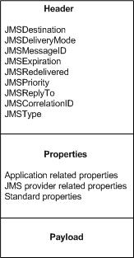
Figure 9: JMS message structure

The payload defines the message body. The message body is of TextMessage type in XML format. This format complies with the definition of event object at the functional specifications:
- Timestamp
- Username
- User group name alias list
- Action
- Impacted object URI
- Related object URI
- Impacted object system ID
- Related object system ID
- Comment

The event objects marshal/unmarshal process are executed by using Spring’s Object/XML Mapping support. This is implemented by using org.springframework.oxm.xstream.XStreamMarshaller. A message body example in XML format is following:

<event>
<timestamp>2012-02-16T19:20:30.45+01:00</timestamp>
<username>admin</username>
<groups>ADMIN_GROUP</groups>
<action>NODE_CREATED</action>
<impactedObjectId>474943</impactedObjectId>
<relatedObjectId>474941</relatedObjectId>
<impactedObjectURI>/Folder</impactedObjectURI>
<relatedObjectURI></relatedObjectURI>
<comment>Text comment</comment>
</event>

Header properties:

Property | Description
JMSDestination | JMSDestination is the destination queue or topic.
JMSDeliveryMode | JMSDeliveryMode for the notification event messages is PERSISTENT. This provides reliability of message delivery from the destination topic to the message consumer. Notification messages are persisted and message loss is prevented. Moreover, topic subscriptions should be durable in order to retain the subscription’s messages until they are consumed or expired. Messages are retained even if the consumers are not active and will be consumed once they are active.
JMSExpiration | JMSExpiration value is the expiration time period (in milliseconds) of the message. Messages are retained in the messaging system for a limited period of time before being expired and removed. Clients does not receive messages that have been expired. The expiration time period is a configurable application property. Once the message server has delivered a message to all of its known subscribers and has received acknowledgments from each of them, the message is removed from the HornetQ journal. The expiration period limits the journal size thus preventing performance issues. An increased journal size can impact the HornetQ server performance depending on the different high availability options. The expiration period should also be long enough to allow client applications to be unavailable for a normal period of time without losing notification messages. The proposed expiration period is one day, which is a good trade off between allowing client applications to perform scheduled maintenance processes and limiting the journal size.

JMS messages also contain application related properties. These properties are the following:

Property | Code | Description
Repository’s object owner username | OWNER_USERNAME | The username of the event related object owner.
Parent folder URI | PARENT_URI | URI. The URI of the event related object’s parent.
Content type | CONTENT_TYPE | The content type name of the event related object.
Event timestamp | EVENT_TIMESTAMP | The timestamp of the event generation
Username | EVENT_USERNAME | The username of the user that executed the event related action
User group | EVENT_USER_GROUPS | A comma separated list of group name aliases of the user that executed the event related action
Action | EVENT_ACTION | The event action
Impacted object URI | IMPACTED_OBJECT_URI | The URI of the impacted repository object
Related object URI | RELATED_OBJECT_URI | The URI of the related repository object
Impacted object UBI | IMPACTED_OBJECT_UBI | The UBI of the impacted repository object
Related object UBI | RELATED_OBJECT_UBI | The UBI of the related repository object
Impacted object ID | IMPACTED_OBJECT_ID | The system’s object ID of the impacted repository object.
Related Object ID | RELATED_OBJECT_ID | The system’s object ID of the related repository object.

The application related properties are used for message filtering by the client applications. The client application are able to fetch notification messages by subscribing to a topic as described above and filters the messages by using message selectors based on the application related properties of the message. Spring messaging provides support for message selectors through the JmsTemplate class by specifying the selector expression. An example of a message selector expression could be: "messageProperty = 'value'".
For example, in order to receive all notification events for the creation of repository objects for a specific object owner, the JMS client will have to subscribe to the topic with name “node created” and filter the received messages by using the owner’s username which is set as an application related property.

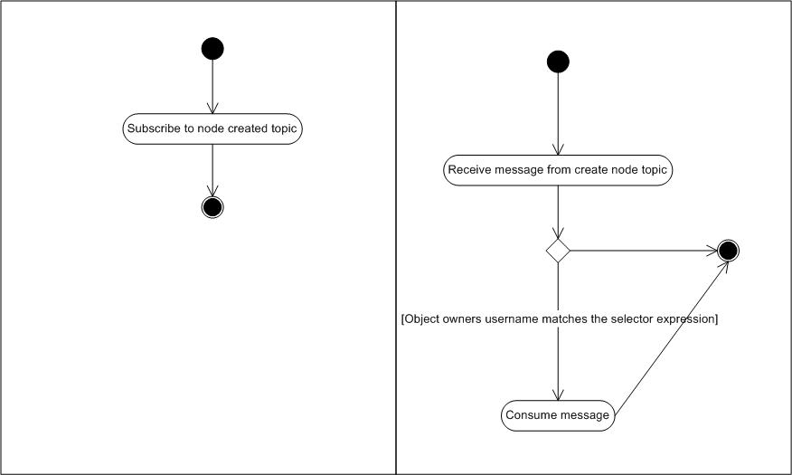
Figure 10: PURE-XML Notification events message consumption activity diagram

Client application need to acknowledge the messages received from the HornetQ server in order to guarantee the message delivery. Messages that are not acknowledged are redelivered from the HornetQ server.

PURE-XML clients have the responsibility of ordering the messages received from the topics and further filtering them according to their needs

If the HornetQ server is not available, PURE-XML events will not be addressed to the JMS destinations. Once the HornetQ server recovers and the quartz scheduler is executed, the HornetQ server receives all event messages that have been created during the unavailability period. Persistent messages and transacted sessions prevents message loss.

Web Services

The proposed PURE-XML architecture design supports web services exposure through future extensions. The following figure depicts how web services would participate in the application architecture. The web services would extend the application/business tier of PURE-XML. Apache CXF framework would be used in order to provide support for web services exposure via JAX-WS or JAX-RS. Apache CXF provides annotation support for Web Services configuration. The Web Services integration is depicted in the following diagram:

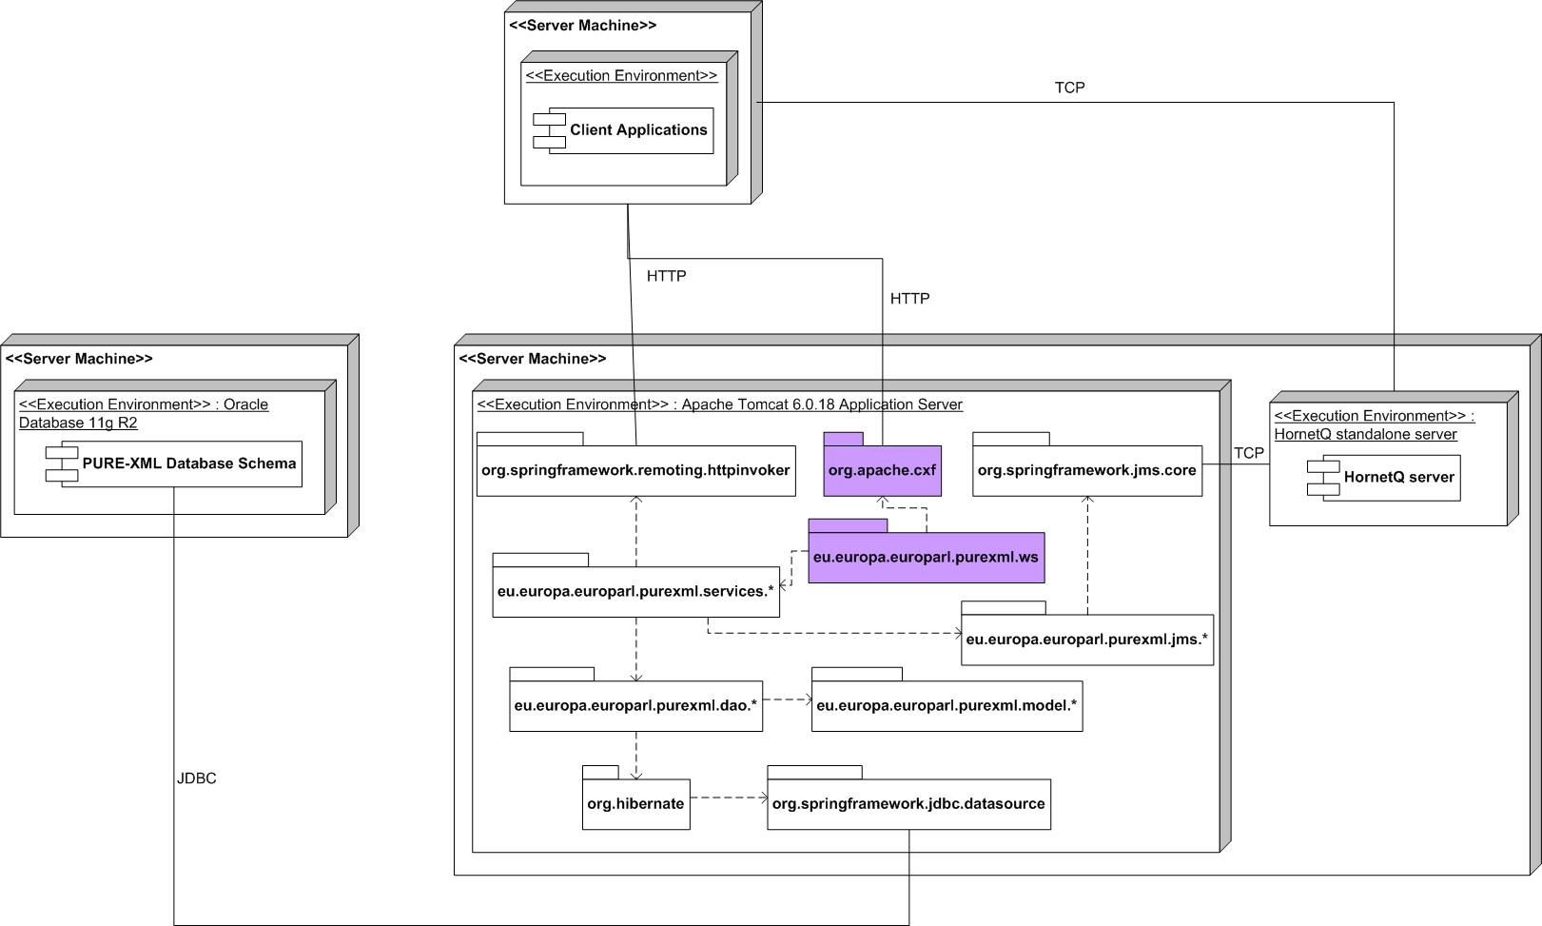
Figure 11: PURE-XML Web Services integration

Deployment view

The following diagram displays the deployment model of the PURE-XML application:

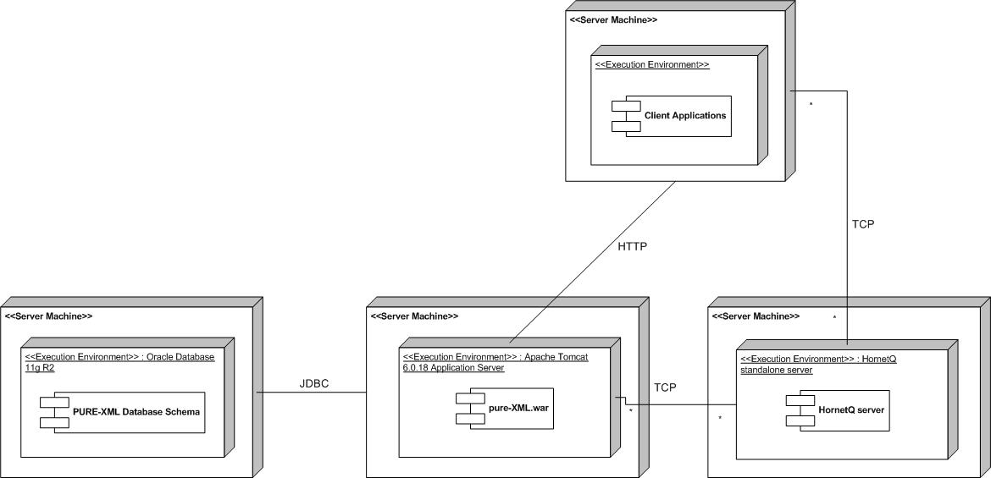
Figure 4: PURE-XML High Level Deployment model

PURE-XML is deployed on EP Apache Tomcat application server as a Spring web application archived as WAR and according to the EP packaging standards. The deployment files are created by Apache Maven build tool.
Client Applications can be implemented in Spring as they are able to integrate with PURE-XML over HTTP. The envisaged type of integration between PURE-XML and EP clients is HTTP,

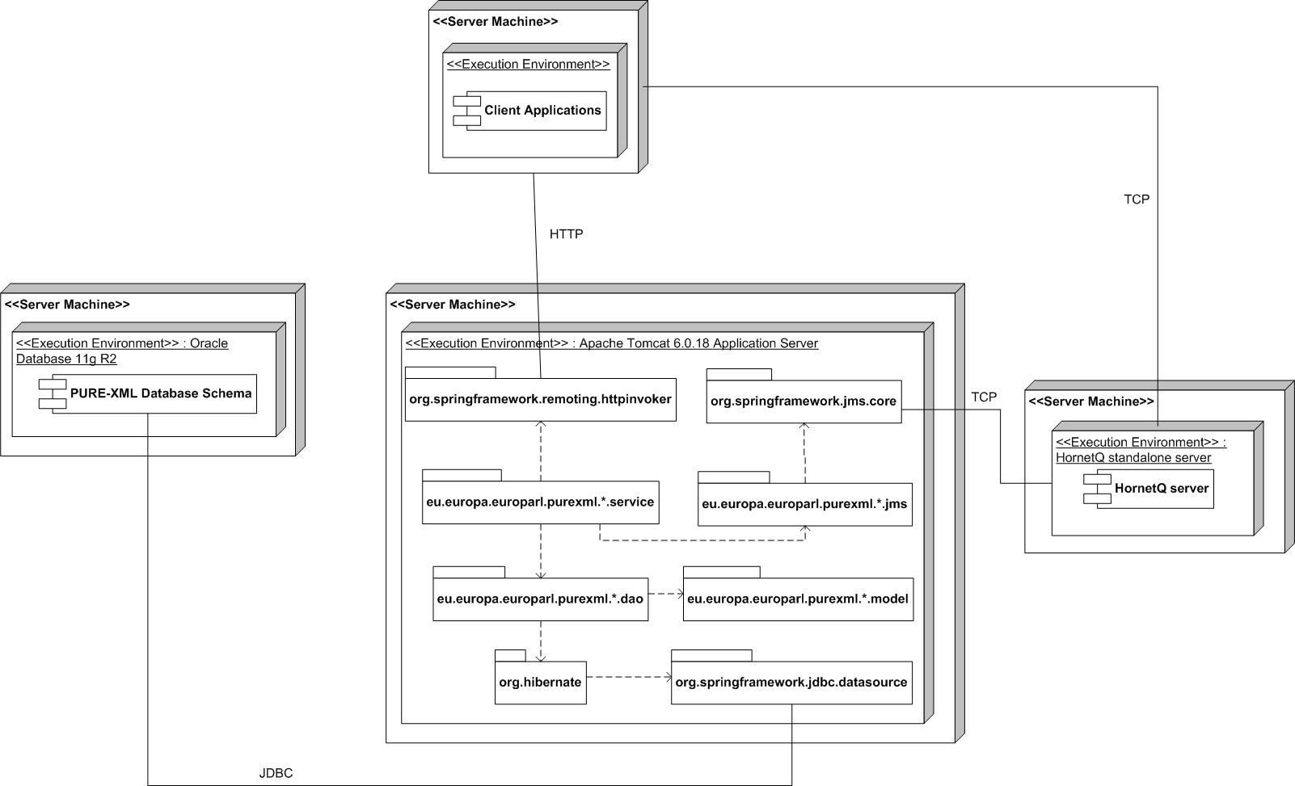
Figure 5: PURE-XML component integration

Hardware requirements
Apart from the database server, the following infrastructure is expected to be used in single-node installations:

- one virtual machine to host the application server
- one virtual machine to host the standalone JMS installation

In case of a high-availability setup, additional virtual machines should be added in the environment to host more application server instances. One more virtual machine may be needed to host the reverse proxy, in case a central reverse proxy is not in use in the EP.

The exact hardware resources of each virtual machine (Solaris zone) will be defined after performance testing the application.

Software requirements

The system respect the following software requirements:

- Application Server: PURE-XML is developed according to EP and Apache Tomcat specifications.
- Application Framework: Spring is used throughout for the development of PURE-XML. In particular, PURE-XML is based on Spring remoting integration classes which offers support for exposing the API over HTTP.
- Build Tool: PURE-XML utilizes Apache Maven in order to manage the full development cycle, including build, reporting and documentation processes. All required scripts are part of the PURE-XML deliverable. Apache Maven is used to automate PURE-XML installation procedure in the different application environments.
- Data Storage: PURE-XML uses Oracle 11g R2 Database with XML DB extension. Oracle Database is used to store both relational and XML data. See Annex V: Performance Comparison of Storage Technologies for reasoning on the selection of the Oracle XML DB extension.
Data Indexing: Oracle Text is used for text queries against the database. Oracle Text is utilized to increase the performance of text search over PURE-XML repository content data. Oracle Text indexes are created on the repository’s content data columns that are stored in the database or data snapshots preserved in materialized view REPOSITORY_OBJECT_SEARCH_MV. Text search queries against the content data uses Oracle Text SQL statements and operators and the query results are ordered based on the scoring of the Oracle Text algorithm. The context index is automatically be updated using the “SYNC EVERY” DDL construct. The updates of indexes and materialized view are issued on application level, depending on usage pattern The Access Control permission check is not built in the search queries since this would involve the execution of hierarchical queries that could lead to performance degradation. The Access Control permission check is performed on the limited search results.
- Data Persistence Framework: PURE-XML uses Hibernate implementation of JPA for database persistence.
- Asynchronous remoting: HornetQ is used for JMS implementation providing asynchronous communication between different components. The client applications are able to receive notification messages based on the Publish-Subscribe JMS messaging pattern. Publish-Subscribe messaging pattern decouples the application from the transport layer of providing data to the PURE-XML client applications.

Installation

PURE-XML application is installed in the following environments:

Environment | Description
DEV | Development environment
INT | Integration environment (optional)
PPO | The pre-production environment
PROD | The production environment

The installation procedure is documented in the Setup Guide document, according to EP standard methodology. High level description of the installation steps:

- The Oracle database scripts are executed on PURE-XML’s database schema using SQLPlus
- Apache Maven scripts handles the configuration and deployment of the application on Apache Tomcat and HornetQ standalone server.

Configuration

PURE-XML application provides automated build facilities through Apache Maven. The configuration attributes of PURE-XML are stored in configuration files that vary for each application environment. In this way, an automated configuration mechanism is provided with the application source code.
Moreover, the application environments are configured as follows:

Environments
DEV | Tomcat, Java 1.6.0, HornetQ, Oracle 11gR2 with XML DB
INT | Tomcat, Java 1.6.0, HornetQ, Oracle 11gR2 with XML DB
PPO | Tomcat, Java 1.6.0, HornetQ, Oracle 11gR2 with XML DB
PROD | Tomcat, Java 1.6.0, HornetQ, Oracle 11gR2 with XML DB

Quality control requirements

During the PURE-XML application development, the Sonar platform is utilised in order to evaluate the quality of the delivered source code, based on EP quality standard metrics. The application source code shall be compliant to the following metrics:

Metric | Threshold
Methods Cyclomatic Complexity | <= 7
Method test Coverage | >= 70%
Rules Compliance | 0 blocking violations  0 critical violations
Duplications | <= 5%

External libraries and auto generated code are excluded from the above metrics. The application source code is documented through Javadoc comments. Comments are not needed for simple constructors and access methods (set/get). Method names are self explanatory and the related method comment adds important information other than the obvious one conveyed by the method name. Every class is commented and its purpose and usage clearly stated in its comments.

Testing requirements

The testing of the PURE-XML application aims to verify that the developed application abides to the performance and functional behaviour described in the functional specifications (applicable document 1).
Application performance, load and stress testing are performed based on the EP repository data size described in PURE-XML sizing (reference document 1). The application is able to respond within response-time delays that have been defined by the EP at the time of ordering the implementation of specific functionalities. .Apache JMeter has been used to stress test the application before delivering it to the EP. The test scripts are also delivered to the EP to serve as a common base for comparing test results.
Functional testing guarantee the functional behavior of the application API. Both functional and performance tests have been executed using the PURE-XML Management Console as a main testing instrument. Nevertheless, for the whole implementation, JUnit tests are delivered and included in the Maven project.

Description of database model
The presented database model is the current physical model.
Database model
The PURE-XML database relational model is depicted below:

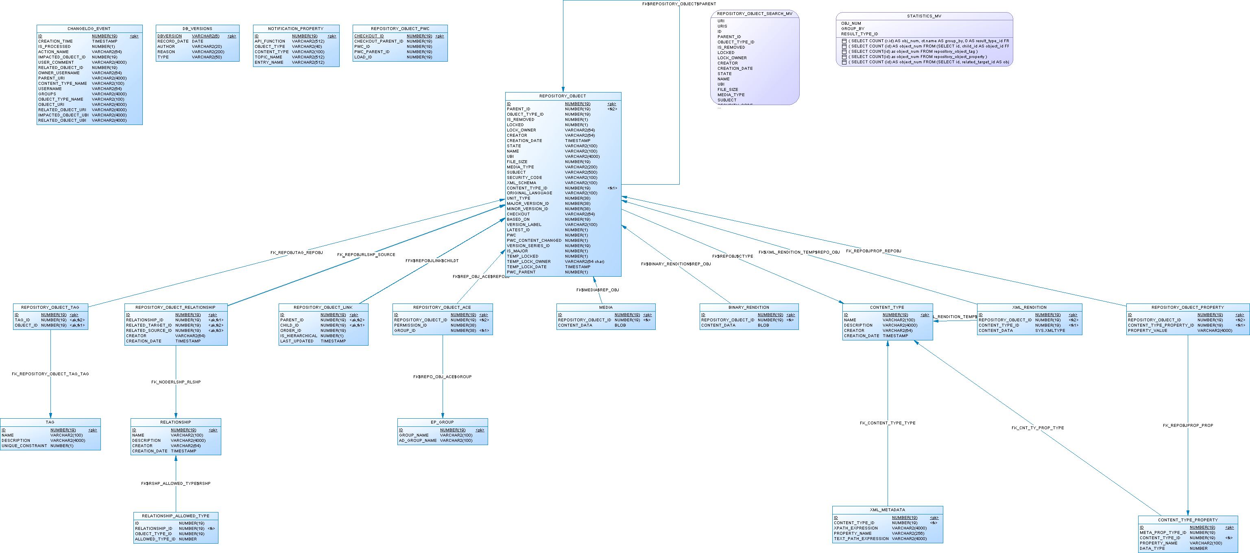
Figure 12: PURE-XML ER model

The PURE-XML database stores both relational and XML data using Oracle XML DB extension. XML data is stored in XMLType columns. The XML data storage type is binary.
Displays and describes a graphical view of the database schema.

Data dictionary
The main functionalities of PURE-XML to be supported by the PURE-XML DB schema are summarised in the following:
- fully support the PURE-XML object model (derived from the IRO model) and its versioning schema
- provide central storage and search facilities for XML-oriented content
- must provide access control management functions
- provide notifications and changelog mechanism that keeps history of modification changes
The table structure is listed in the Annex of this document.

The PURE-XML data model will fully support the PURE-XML object model (derived from the IRO model) and its versioning schema.

Figure 7: ER – Repository objects

REPOSITORY_OBJECT table This is the central table inside the repository and a generic container for all objects that enter the repository. All objects have references to the REPOSITORY_OBJECT table. The parent is defined via the PARENT_ID property. The type of the object is defined via a reference in column OBJECT_TYPES_ID.
REPOSITORY_OBJECT_PROPERTY table
This table stores properties for the existing objects. It references the CONTENT_TYPE_PROPERTY table for its values.

REPOSITORY_OBJECT_LINK table
This table contains parent-child relationships between the objects. It contains an indicator classifying links as parent-child (containment) relationships or links. It has a check constraint which ensures that an object can have only one parent. Information about the parent may be duplicated (slightly de-normalized schema) for performance reasons. Apart from hierarchical structure, this table can also contain link to the nodes; distinguishing between these type of relations is represented in the IS_HIERARCHICAL column.

REPOSITORY_OBJECT_PROPERTY table
Intermediate table for copying repository objects.

BINARY_RENDITION table
Table stores binary data for repository objects.

XML_RENDITION table
The table stores XML renditions i.e. the physical manifestation of a given linguistic version. Content is stored as XMLType with binary storage option. The binary storage gives flexibility because metadata are stored with the data, so schema changes are handled easily. XMLs will be validated on application level upon reception ensuring that only valid XMLs enter the system. Indexation will be done using a combination of XMLIndex (check CONTENT_TYPE_METADATA table) and Oracle text index.

XML_METADATA table
Table which contains content types XML metadata.

MEDIA table
This table stores information about media which is a file-derived object for the various media (images, etc) that are not supported by the Rendition format. The storage type is a simple BLOB, stored in separate tablespace.

CONTENT_TYPE table
The table stores information about various content types. The Content-Type will be assigned at the level of the Logical Units. The Physical Units and the Renditions inherit automatically the Content-Type of their parent. The Content-Types allow the client applications to define custom properties related to their content or their business workflow.

CONTENT_TYPE_PROPERTY table
The Content-Types allow the client applications to define custom properties related to their content or their business workflow. Content-Type properties are managed independently of the XML content and they can be updated and modified without the need of the check-out/in change and versioning operations.

RELATIONSHIP table

This table contains user defined relationships between the objects.

REPOSITORY_OBJECT_RELATIONSHIP table

This table maintains the internal "Related-source" and "Related-target" properties for each object that supports relationships.

TAG table

Contains description of a tag.

REPOSITORY_OBJECT_TAG table
Association of a tag with repository object

REPOSITORY_OBJECT_ACE table

Contains the list of permissions for a particular repository object given to a particular group.
The PURE-XML repository must provide access control management functions for all the repository objects that require ACL support. The permissions must apply to the current object and all inheriting objects, recursively. This is achieved by using Node’s column ABSOLUTE_PATH, which is constructed as follows:
ABSOLUTE_PATH = parent’s ABSOLUTE_PATH + “/” + id (e.g. /123/35/546)
To speedup search on this column, an index will be created.

In order to avoid expensive checks during the read phase, recursive propagation of permissions will be done during the creation phase of each ACE. Also, when new repository objects are created, all permissions will be copied from the parent. In this way, all necessary checks will be done at the object level, avoiding the need to traverse through the hierarchy of objects.

There are two cases:
- when new permissions are defined for a group, one additional SQL statement is invoked, in the same transaction, to update the ACEs for all child objects (SQL will contain a section similar to “… WHERE ABSOLUTE_PATH LIKE ‘$PATH%”, where $PATH is updated object’s ABSOLUTE_PATH)
- when permissions are assigned directly to an object, an additional statement will be invoked in the same transaction to create ACEs for all child objects. The difference will be the fact that the DIRECTLY_ASSIGNED flag will be set only for the original object

This method simplifies the checking of ACLs for an object and thus increases the speed of retrieval, since only the ACL of the requested object needs to be consulted to determine whether the user has appropriate permissions or not. Furthermore, all checks will be done in a simple SQL query.
Example 1:
- user asks to update Repository object with ID=5
- user’s group has internal id=10
- ID for “update” is 5
The retrieval of the document will be done using the following SQL query:

SELECT *
FROM REPOSITORY_OBJECT
WHERE ID=5
AND EXISTS (SELECT NULL
FROM REPOSITORY_OBJECT_ACE
WHERE REPOSITORY_OBJECT_ID=5
AND GROUP_ID=10
AND PERMISSION_ID=5)
An indexes on (REPOSITORY_OBJECT_ID, GROUP_ID , PERMISSION_ID) are created to increase access speed to ACL.
The return result can be tested against NULL constraints to check whether an object is returned or not.

The permissions associated in this table are defined in PERMISSION_ID column. The following table contains values that mark the specific privileges; These are set in the hierarchical model (each next level includes all access rights of the previous levels as well).

Level | Name | Allowed functions
0 | none | No access.
1 | read | Permission to read the object's properties and content.
2 | relation | Permission to create relationships on this object.
3 | version | Permission to create new versions.
4 | create | Permission to instantiate new children in the object.
5 | update | Permission to update the object's properties and content.
6 | delete | Permission to remove an object.
7 | admin | No restrictions.
. These permissions can be combined.

EP_GROUP table

All the groups that can be used in the ACL entries have to be defined. The group name shall correspond to the name of the groups/roles provided by the authentication module

CHANGELOG_EVENT table

PURE-XML must provide a notifications and changelog mechanism that will allow client applications to receive notifications and browse the modifications history of the repository's objects.
For this purpose, one table which stores all events is designed: CHANGELOG_EVENT. The following actions will be logged for each object:

Action | Description
node created | Initial object creation.
version created | Creation of new versions for versionable objects
node deleted | Object removal.
node moved | Object relocation.
node linked | Object link creation.
node unlinked | Object unlink operation.
property added | Setting of object's properties (first entry).
property changed | Modification of object's properties.
property deleted | Removal of object's properties.
content changed | Updating of object's content-data.
ACL added | Setting of access control entries.
ACL changed | Modification of access control entries.
ACL deleted | Removal of access control entries.
relation created | New relationship.
relation deleted | Removal of a relationship. The related Object ID is the Relationship object.
tag added | Tag addition.
tag deleted | Tag removal. The related Object ID is the Tag object.

Software Architecture
In this paragraph the software architecture of the system is described, in accordance with PMM4EP. This description follows a structure similar to that definite for logical architecture of the document of functional specifications
The writer will attempt to describe:
- The classes which significantly changed compared to their description in the document of functional specifications
- the technical classes
During the description of the scenarios, it will privilege the exchanges with the technical classes.
Moreover for each scenario, the writer will be able to include any element which it will consider relevant (screens, reports, business rules…).

Static view
The PURE-XML application contains the following main packages:

Package | Description
eu.europa.europarl.purexml.services | This package contains the service layer of PURE-XML. This layer exposes the PURE-XML API services and implements the business logic. The implementation of this package contains data validation based on business rules that are defined in the functional specification. Also, this package implements the model entity object construction. Spring’s dependency injection container is used to decouple the service from the DAO and the JMS integration. The service package invokes the relative DAO and the JMS methods in order to integrate with the database and the HornetQ server. The domain model data transfer objects are used as method parameters. In this way the service layer is decoupled from the database and the JMS integration implementation details. This design increases the code re-usability and provides a standard structure.
eu.europa.europarl.purexml.dao | The DAO layer is implemented in this package. The DAO layer acts as an adapter between the API and the data source by hiding the database implementation details from the service layer and by providing standard reusable database implementation. The service layer invokes DAO methods in order to retrieve or persist data in the database. Domain model entity classes are used for this through Hibernate implementation of JPA.
eu.europa.europarl.purexml.model | This package contains the domain model entity classes. These classes are annotated with hibernate annotations in order to provide the mapping information with the database schema. These classes are used for data retrieval and persistence at the database through Hibernate implementation of JPA. Also, the model entities are used for JMS message body creation in XML format.
eu.europa.europarl.purexml.jms | This package contains the JMS integration of PURE-XML. The JMS package is used in order to decouple through Spring’s dependency injection container the service package from the JMS integration and increase the code reusability. The service package uses the JMS package to integrate with HornetQ server. JMS messages are published to the HornetQ destinations. The domain entity objects are marshaled by using Spring’s Object/XML Mapping support to XML that constitutes the JMS message body.
eu.europa.europarl.purexml.annotation | This package contains Annotations that are used to decorate service methods. The annotations are used by aspects for the implementation of method interception.
eu.europa.europarl.purexml.aspects | This package contains Spring AOP aspects. AOP advices for specified join points are used for method interception. Selected service methods are intercepted through this implementation. This package handles the interception execution. This design increases the modularity by allowing the separation of cross-cutting concerns, such as the notifications event and the activity usage logging. The aspects use the relative service methods that will implement the business logic of method interception.
eu.europa.europarl.purexml.scheduler | This package contains the scheduled jobs that will be executed periodically. The schedulers use the relative service methods that implement the business logic of the scheduled process.
eu.europa.europarl.purexml.client | This package contains the PURE-XML API implementation as described at the functional specifications. PURE-XML JAR file contains these classes that are used to decouple the repository client applications from integration details and also hide the API implementation details from the API user. This package does not implement business logic but invokes the service layer for this.
eu.europa.europarl.purexml.dto | This package contains the Data Transfer Objects of PURE-XML. The domain model entity objects are converted into DTO objects at runtime. DTOs are used by the service layer. This design pattern is used in order to decouple the service layer from the domain model entity objects.
eu.europa.europarl.purexml.enumeration | This package contains Enumerations.
eu.europa.europarl.purexml.util | This package contains utility classes.
eu.europa.europarl.purexml.exceptions | This package contains the PURE-XML provided exceptions. The relevant error codes are presented in Annex I section.

The main packages and package dependencies are depicted in the following diagram:

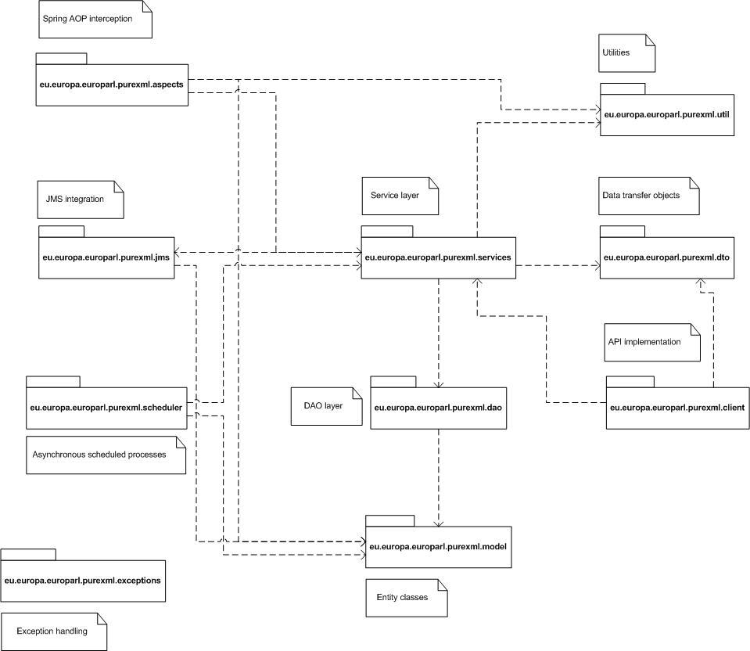

The PURE-XML application contains the following main functional components based on the functional specifications:

Component | Description
Repository | This application component provides all object level CRUD methods following the PURE-XML content model.
Content types | This application component provides support for the definition of the Content Types and their properties.
Relationships | This application component provides support for the creation of user-defined relationships between the repository’s objects.
Tagging | This application component provides support for the creation and assignment of user-defined tags to the repository’s objects.
Versioning | This application component provides support for the PURE-XML versioning model.
Access Control Management | This application component provides access control management functions for all the repository objects that require ACL support.
Changelog | This application component provides support for the changelog management. Changelog provides information for the modifications history of the repository objects.
Locking | This application component provides support for the locking mechanism of the repository’s objects.
Notifications | This component provides support for the notification event processing. The notification events are logged and sent to the notification receivers.
Connector | This component connects the different application components and provide access to the exposed API.

The notifications component uses Spring AOP techniques and act as a method interceptor for every method invocation that requires event notification or logging based on the functional specifications. The event processing is executed after the initial method is invoked and returned. Notification event processing is depicted in the following sequence diagrams:

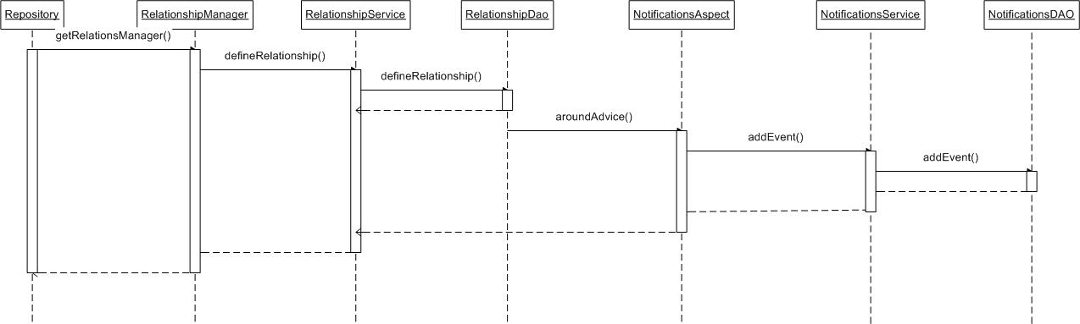

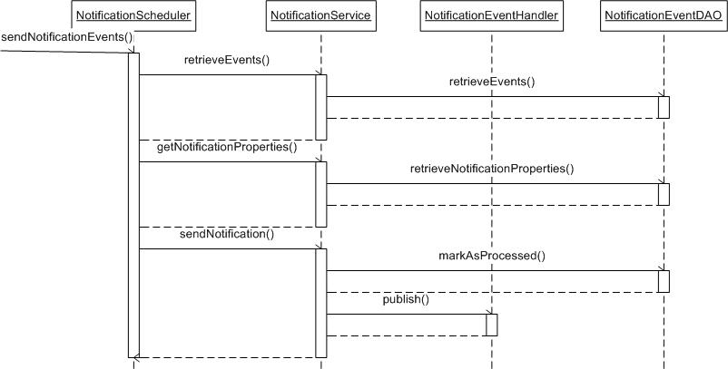

Notification persistence is implemented by using the “around” advice of Spring AOP module, which will take action for the specified join points. These join points are the execution of methods that require notification or logging processing based on actions that are defined in the functional specifications. The join points are predicated by AspectJ pointcut expression language.

This architectural decision increases the modularity and separation of cross-cutting concerns and also provides advantages in terms of maintenance and extensibility. In case that the notification component needs to be extended in order to support additional repository actions, the architectural design will need to be modified by adding more dependencies and introducing more complexity. By using Spring AOP techniques, this is avoided and further extensions can be adopted by specifying additional pointcut expressions to the aspects.

Cross-cutting concerns are organized around Spring’s built-in declarative operation management or its aspect-oriented facilities.

Aspect | Annotation | Description
Cache | @Cachable  @CacheEvict | The Spring cache abstraction. It is defined on the service layer and it is selectively applied to API methods based on performance metrics and usage patterns.
Transaction management | @Transactional | The Spring transaction support management.
Notifications | @NotifyClients | The repository notification tracking implementation. It is executed on service methods that require notification support. The repository objects are declared by using Spring SpEL expressions over the method parameters.
Validation | @Validate | The repository objects validation implementation. It is executed on service methods that require validation support. The repository objects are declared by using Spring SpEL expressions over the method parameters.
Exception handling | Join point | Handles the exception translation of repository unchecked exceptions to application specific exceptions.
Permissions | @CheckPermission | The repository permission verification implementation. It is executed on service methods that require permission verification support based on ACLs. The repository objects are declared by using Spring SpEL expressions over the method parameters.
Locking | @CheckLocked | The repository locking management implementation. It is executed on service methods that require locking check support. The repository objects are declared by using Spring SpEL expressions over the method parameters.
Root object restriction | @CheckRoot | The repository root restriction management implementation. It is executed on service methods that are restricted for the root repository object.
Profiler | Joint point | The repository logging and profiling implementation. It is executed on service methods.
Security token validation | Joint point | The repository object security token implementation (see section 3.2.4).. It is executed on service methods.
Session management filter | Join point | The repository HTTP session management implementation. It is executed on service methods.

The repository component implements the repository object management described in the functional specifications. The API implementation classes contain data transfer objects that hold the repository’s object properties after the class instantiation. Once the Node object is retrieved from the database and instantiated, it can be an instance of: Folder, LogicalUnit, PhysicalUnit, Rendition (XML and Binary) or Media class based on it’s object type. Data retrieval methods that are invoked through Node instance fetches data from the data transfer objects and not through another database lookup. The node’s system and content properties are loaded via data transfer objects. The content properties are using this loading mechanism only when they are loaded as collection of nodes through any getChildren API method. Content data is always loaded directly from the database. In the case that an API user A retrieves a node (including the properties) and after that another user B modifies a property of the same node, then user A should fetch a new instance of the node in order to get the modified value. System property updates are not affected since the last updated value per node is persisted in the repository across multiple users. This design reduces the number of database lookups that are executed and avoids heavy database load and it is applied based on performance metrics and the expected API usage patterns. Additionally, it reduces significantly the API response time for frequently accessed methods. This design has been applied to the following API methods:

Method | Loads from data transfer object
Node::getSystemProperty | Always
Node::getSystemProperties | Always
Node::getOrder | Always
Node::getURI | Always
Node::getName | Always
Node::getTypeName | Always
Node::getLockOwner | Always
Node::getCreator | Always
Node::isFolder | Always
Node::isLocked | Always
Node::isLink | Always
Node::isCheckedOut | Always
Node::isVersionPWC | Always
Node::isLatest | Always
IROLogicalLevel::getContentProperty | When node instance is fetched by any getChildren API method.
IROLogicalLevel::getAllContentProperties | When node instance is fetched by any getChildren API method.
IROLogicalLevel::isDocument | Always
IROLogicalLevel::isInformationBlock | Always
IROLogicalLevel::isChunk | Always
IROPhysicalLevel::getContentProperty | When node instance is fetched by any getChildren API method.
IROPhysicalLevel::getAllContentProperties | When node instance is fetched by any getChildren API method.
IRORenditionLevel::getContentProperty | When node instance is fetched by any getChildren API method.
IRORenditionLevel::getAllContentProperties | When node instance is fetched by any getChildren API method.

This process is depicted in the following sequence diagram:

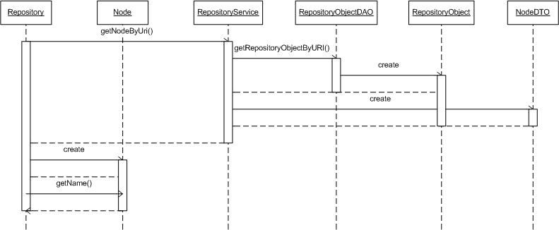

Moreover, Spring cache abstraction is introduced to specified methods in order to reduce the database lookups. Each time a targeted method is invoked, the abstraction will apply a caching behaviour, checking whether the method has already been executed for the given arguments. If it has, then the cached result is returned without having to execute the actual method; if it has not, then method is executed, the result cached and returned to the user so that the next time the method is invoked, the cached result is returned. The annotations used for caching are: @Cachable and @CacheEvict. The @Cachable annotation is used in data retrieval methods specifying the return object and parameter used, while the @CacheEvict annotation is used on methods that persist data in the database. The cache abstraction is integrated with ehcache implementation. Cache management configuration is defined in ehcache.xml. The caching process is depicted in the following sequence diagram:

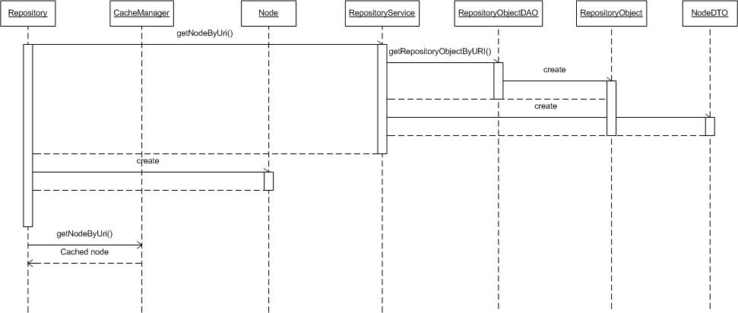

Caching is selectively applied to the API methods.The objects that are using caching are the following repository reference objects:
- Content-types
- Relationships
- Groups
- Tags
The repository CRUD methods and node instances do not use the above mentioned caching mechanism. The @Cachable annotation is used to decorate methods by specifying via Spring SpEL expressions a key for each cache. The key is a unique identifier for each object that exists in cache. The @CacheEvict annotation is used to decorate methods by specifying the same key with the @Cachable method. The eviction is performed during the execution of methods that modify objects that are already in cache and so these objects are removed from the cache based on the specified key which is provided as a method parameter. The server side caching mechanism has been applied to the following API methods:

Cachable | Cache evict | Key
ContentTypeManager::getContentTypeByName | ContentTypeManager::defineContentType  ContentTypeManager::undefineContentType  ContentTypeManager::deleteXMLMetadata | The Content Type name
TagsManager::getTagbyName | TagsManager::undefineTag  TagsManager::updateTagDescription | The Tag name
RelationshipManager::getRelationshipByName | RelationshipManager::defineRelationship  RelationshipManager::undefineRelationship | The Relationship name
AccessControlManager::getGroupByName | AccessControlManager::undefineGroup | The Group name
RepositoryConnector::getRepository | Periodically, the default cache invalidation period is set to 60mins. | The username

Ehcache provides support for replicated caching by using RMI. Cache replication can be configured though Ehcache configuration XML file. RMI replicated caching includes the configuration of CacheManager and CacheManagerPeerListener. For each cache that can be replicated the RMI cacheEventListener will be configured to propagate messages. The replication of cache across multiple nodes is depicted in the following diagram:

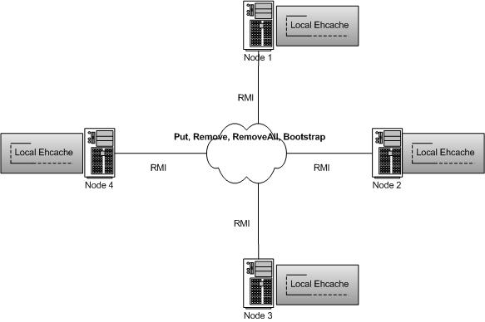

Cache replication can be executed for local cache synchronization on every node. Whenever a cache element is added, updated or removed from the node’s local cache, it can also be replicated to the nodes’ local caches. CacheManagerPeerListener will receive messages from other nodes that will replicate to the local cache of the node. Synchronous delivery can be used in order to avoid potential data inconsistency across the nodes. The replication of the cache will be executed before the API method returns.

Cache replication will add overhead while the caching mechanism will prevent from heavy database load by decreasing the number of database lookups. The additional overhead for cache replication depends on the usage pattern of the PURE-XML API and the cluster size. Frequent CUD operations and increased cluster size will require heavier cache replication.

N.B.: The use of the caching mechanism in a cluster environment (see section on high availability) is not recommended and this option can be evaluated based on the API usage metrics and the cluster size.

Non-functional constraints

Post-incident restart

PURE-XML application serves as an infrastructure application providing a Java API that is used by a number of client applications, including:

- AT4AM
- AT4LEX
- DM-XML
- DST
- CAT4TRAD
- ITER
- EPADES-II

After a post-incident restart all the API method calls that were sent by client applications and the method responses that were pending will be terminated without response. For this reason whenever a restart is executed at PURE-XML’s deployment environment, there should be no usage of the API by the client application that can cause errors.
To minimize the affection of a scheduled application shutdown, we are able to deploy PURE-XML application in a cluster environment. In this case there can always be a cluster node that will be able to serve client applications requests without downtime.

Backup-Restoration
To ensure sufficient level of protection against data loss, physical backup can be used on the database level. For performing backup and recovery based on physical backups, there are two solutions:
- Recovery manager (RMAN) tool which is integrated part of Oracle database. It runs within sessions running on Oracle DB server and has ability to perform range of backup and recovery activities.
- User-managed backup and recovery which assumes that DBA directly manages backup strategy using mixture of host operating system and SQL* Plus commands

RMAN is the recommended solution for database backup and recovery. It provides common interface for backup tasks across different operating systems and offers a number of backup techniques not available in user-managed backups. The database server must run in ARCHIVELOG mode. Some of the backup/recovery tools, such as the HP Data Protector or Symantec NetBackup, take advantage of RMAN scripts ensuring that backup is continuously preserved on tape, shortening recovery time and increasing database availability.

Physical backup can be supplemented with logical backups which can be done on ad-hoc basis using data export utilities. The recommended utility for logical backups is Data pump.

The only information stored outside the database is the HornetQ journal. However, this information is volatile and only has temporary value. More specifically, any message stored in a JMS topic has value only before its expiration. Based on the proposed expiration period of one day, a backup procedure for these files is not of much value, since any backed up information would be of no use shortly after being stored to a backup medium. Consequently, the recommended way of minimising the consequence of data loss at the HornetQ server is to use one of the high availability solutions proposed in the next section.

High availability
The PURE-XML application is the sole repository for all EP applications. As such, high availability is a recommended attribute, in order to ensure the smooth operation of services that rely on the PURE-XML repository. The overall degree of availability of PURE-XML depends on EP infrastructure limitations.

Application level
High availability at EP premises is achieved through failover or a reverse proxy distributing the sessions to multiple servers at the application level. In this respect, PURE-XML can achieve application-level high availability by being installed on multiple application servers behind a reverse proxy. In this configuration, when an application server fails, new requests will be routed to another live application server. This configuration however does not provide session replication.
The recommended approach is to utilise a separate (virtual) machine for each application server installation.

Database level
The database is a single point of failure for the PURE-XML system, if no appropriate measures are taken. Oracle Real Application Cluster (RAC) provides high availability for applications, so that the database server is no longer a single point of failure. If a node in a server pool fails, the Oracle Database continues to run on the remaining servers in the pool. In addition to RAC, Physical Standby database (via Oracle Data Guard or Oracle GoldenGate) can be used to eliminate downtime in case of storage failure. This configuration is transparent to the application.
High availability on the database level is not guaranteed, since in EP premises the database is set up to work on single servers instead of RAC.

Messaging level
HornetQ server achieves high availability by using a failover cluster. In this scenario, the HornetQ cluster replicates data from the live server journal to the backup server. The HornetQ journal consists of a set of files on the disk and is used for the persistence of messages and transactions. When a failover occurs, the backup journal will contain all persistent messages that have been addressed to the live server. This requires configuration on the live and the backup servers’ hornetq-configuration file. Data replication introduces performance overhead compared to non replicated operation, but has the advantage of requiring no shared file system for failover.

Another option to achieve high availability is to use shared file system for the HornetQ journal. Both the live and backup server will share the same high availability storage. In case of a failover the backup server takes over and loads the persistent storage from the shared file system. The advantage of shared-store high availability is that no replication occurs between the live and backup nodes, thus no performance penalties due to the overhead of replication during normal operation are imposed. The disadvantage of shared store replication is that it requires a shared file system, and when the backup server activates it needs to load the journal from the shared store which can take some time depending on the amount of data in the store.

Taking into account that performance is the major design consideration of PURE-XML, the option of shared storage for high availability is recommended.

In case such a high availability storage option is not available, clients can request events from PURE-XML via the API methods available for the changelog. However, in this case, the clients should be able to re-synchronise with the messaging system when it becomes available again. The PURE-XML application will send all messages that were not successfully delivered to HornetQ after HornetQ resumes operation.

Security constraints

PURE-XML provides an authentication mechanism of client applications and authorization of the API users. Authentication is needed to confirm the identity of the applications. This identity information is used by the system for different reasons (logs, audit, caching, security, role management, authorisation, etc).

PURE-XML is called by other systems on behalf of the users. In this case PURE-XML needs to determine the applications and users originating the request. This is performed in a two-steps process.

Authentication

Authenticating applications

PURE-XML authenticate all the client applications that request a connection via its API. The authentication of the client applications is possible by using a local configuration file that includes the credentials of the client applications. The applications are granted access only if they are listed in that file and provide the correct password.

PURE-XML offers access to its API through HTTP. Client applications through the implementation of the API use Apache HttpComponents to provide the credentials through HTTP requests. Subsequent calls from the clients re-use the established session and thus won’t require authentication. Apache HttpClient caches the client credentials that have been successfully authenticated and authentication data are propagated throughout HTTP requests. Apache Tomcat validates client’s requests against property files and provides access to the clients. Apache Tomcat uses the JAAS PropertiesLoginModule which provides authentication againts property files.

Authenticating users

The user information is propagated from client application to PURE-XML and the repository accepts it as trusted.

Authorization

The PURE-XML repository provides access control to its content based on group membership of the calling user.

The groups that are used for the PURE-XML access control lists are locally defined (see API functions AccessControlManager::defineGroup, and AccessControlManager::undefineGroup) and must correspond to EP Active Directory groups. These groups must be defined in AD previously via IT support requests.

All the client applications provide the username of the user on behalf of which they are operating when opening the connection to the repository (see API function Repository::getRepository).

N.B.: Client applications communicate only the username and not its password.

PURE-XML obtains the group membership of the provided username from the EP Active Directory. The connection is denied if the provided username is not found in the EP Active Directory or the locally defined repository groups.

The user's groups are cached locally in order to avoid multiple queries for the same user. The following diagram presents graphically the data exchange.

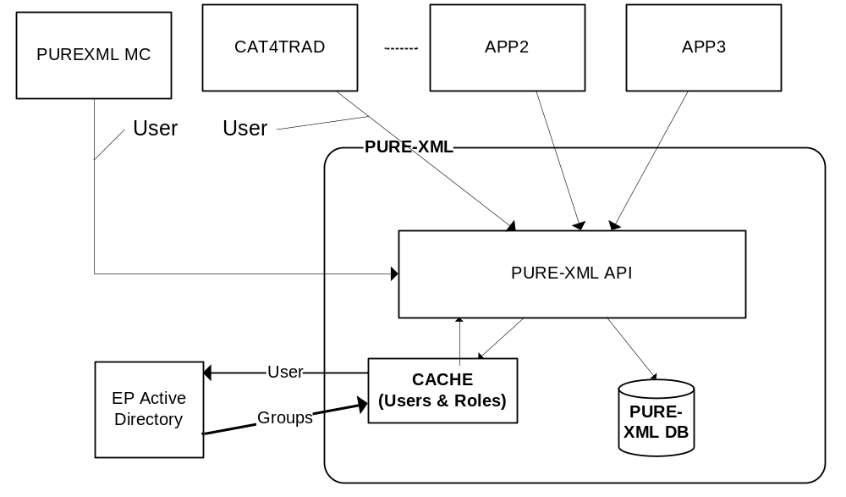

Multiple user sessions are allowed under a client application’s connection. PURE-XML provides fine grained access control to its API and repository objects. Permission levels and authorized user groups are directly assigned to the repository objects through Access Control Lists. PURE-XML provides access control management functions for the repository objects and the user groups. Access control and access control management are performed on application level.

PURE-XML provides a security mechanism for malicious client application's source code. The RepositorySession class is used for the security context caching and propagation. The RepositorySession instance holds the user's groups/roles and the name. Possible modifications of its content consists a potential security risk. The following implementation is used to protect from the modifications of its contents:

- RepositorySession is declared as immutable object in order to protect from potential modifications of its content.
- The RepositorySession object holds a security token with a hashed value (SHA-1). This value is unique per repository session instance.
- The node instances contain a security token that defines the repository session object that was used for the instantiation of the object on the server side. This implementation secures that each node can be used only by a single session. The security token contains a unique hashed value per node and session. The security token of each node instance is validated on the server side upon each request.

Associated unit tests

Unit test classes are associated with PURE-XML Java API in order to ensure that each method is executed as expected in isolation. The associated unit tests provides 70% method coverage of the application API, focusing on the methods as described on the functional specification document.

This section describes the minimum unit tests to be carried out by the developer to check the proper development of his module. The tests are for guidance and cannot replace a comprehensive test plan.

Annex I: Application Error Codes

The default business error messages are as follows:

Error code | Message
1001 | Insufficient permissions
1002 | No space available
1003 | Invalid properties
1004 | Parent is not a Folder Object
1005 | Folder name unique constraint violation
1006 | Object is not empty
1007 | Child Object name already exists
1008 | Object creation constraint violation
1009 | Invalid content data
1010 | File already exists
1011 | Logical Unit name unique constraint violation
1012 | Logical Unit hierarchy constraint violation
1013 | Object name already exists on the target
1014 | PURE-XML content containment rules violation
1015 | A Physical Unit for the same language already exists
1016 | Parent is not a Logical Unit object
1017 | The Physical Unit is not empty
1018 | Parent is not a Physical Unit object
1019 | Invalid Object (Parent is not a PWC object)
1020 | Content-Type already in use
1021 | No Content-Type found
1022 | Relationship already in use
1023 | No relationship found
1024 | Invalid relationship
1025 | Not allowed target object type
1026 | Relationship already exists
1027 | Tag already in use
1028 | No tag found
1029 | Tag already exists
1030 | Object checked-out by user
1031 | Object is not checked-out
1032 | Group already in use
1033 | No group found
1034 | Invalid ACE
1035 | The URI does not correspond to a repository object
1036 | The object is locked
1037 | The object is not the latest version of the version sequence
1038 | Object not found or invalid URI
1039 | The object is PWC
1040 | The target object contains reference
1041 | Hierarchy rule constraint violation
1042 | Object name unique constraint violation
1043 | Invalid object type
1044 | The object is temporarily locked
1045 | The object is not already locked
1046 | The user is not the lock owner
1047 | The physical unit object is not empty and has a media object child
1048 | Empty xpath expression
1049 | The target and parent object is the same
1050 | Deletion of content-type properties is not allowed
1051 | Deletion of content-type XML metadata is not allowed
1052 | Changelog cleanup is currently executing, parallel execution is not allowed
1053 | The target parent content-type is not valid. The parent content-type should be the same with the child content-type
1054 | The UBI already exists
1055 | No Content-Type XML metadata found
1056 | The XML content value exceeds size limits
1057 | Group name already in exists
1058 | ACE already exists for this object
1059 | ACE is not found for this object
1060 | The object is not versionable
1061 | The children list is invalid
1063 | Invalid search query
1064 | Invalid dates
1065 | Not supported action for the root object
1066 | Tag unique constraint violation
1067 | Invalid XPath expression
1068 | The relationship's object type is already used
1069 | Active Directory group name already in exists
1070 | You cannot delete the PWC. Use "cancel checkout" instead
1071 | The target and source is the same node
1072 | The rendition nodes cannot be moved
1073 | Renaming of PWC is not allowed

The default system error messages are as follows:

Error code | Message
1080 | Data access exception
1081 | JMS access exception
1082 | Transaction commit failure exception
1083 | Invalid PURE-XML repository URL
1084 | System general error
1085 | Invalid username. No groups/roles are found for this user in the Active Directory
1086 | Invalid username. No groups are found for this user in the repository
1087 | Invalid Pure-XML Java API version
1088 | Cannot connect to the LDAP server
1089 | Cannot search for groups/roles at the LDAP server. The search base is misconfigured

Annex II: Software Requirements Details

Software | Version
HornetQ | 2.2.15.Final
Apache Tomcat | 6.0.18
Oracle Database | 11g R2
Spring | 3.1.0.RELEASE
Apache Maven | 3.0.4
Ehcache | 2.5.3
Hibernate | 4.1.1.Final
Apache HTTP Client | 4.2
Apache HTTP Core | 4.2
Xstream | 1.2.2
Apache Log4j | 1.2.16
JUnit | 4.7
EasyMock | 3.1
Apache JMeter | 2.7
PowerMock | 1.4.12
Quartz Scheduler | 1.7.3

Annex III: Data Structure Details

Table BINARY_RENDITION

Card of table BINARY_RENDITION
Name | BINARY_RENDITION
Code | BINARY_RENDITION
Comment | Table containing binary data for repository objects.
Primary Key | PK$BINARY_RENDITION$

List of columns of the table BINARY_RENDITION
Name | Comment | Data Type
ID | System generated ID. Populates from BINARY_RENDITION_TEMP_seq | NUMBER(19)
REPOSITORY_OBJECT_ID | Referential Repository Object | NUMBER(19)
CONTENT_DATA | Binary data | BLOB

List of indexes of the table BINARY_RENDITION
Name | Code | Unique | Table
IX$BINARY_RENDITION$REPOBJ | IX$BINARY_RENDITION$REPOBJ | FALSE | BINARY_RENDITION

List of outgoing references of the table BINARY_RENDITION
Name | Parent Table | Foreign Key Columns
FK$BINARY_RENDITION$REP_OBJ | REPOSITORY_OBJECT | REPOSITORY_OBJECT_ID

Table CHANGELOG_EVENT

Card of table CHANGELOG_EVENT
Name | CHANGELOG_EVENT
Code | CHANGELOG_EVENT
Comment | Table which contains Changelog events
Primary Key | PK$CHANGELOG_EVENT

List of columns of the table CHANGELOG_EVENT
Name | Comment | Data Type
ID | System assigned ID. Populates from changelog_events_seq | NUMBER(19)
CREATION_TIME | Timestamp when even has been created | TIMESTAMP
IS_PROCESSED | Flag showing if event is processed | NUMBER(1)
ACTION_NAME | Action | VARCHAR2(64)
IMPACTED_OBJECT_ID | Impacted object | NUMBER(19)
USER_COMMENT | Comment | VARCHAR2(4000)
RELATED_OBJECT_ID | Related repository object (FK) | NUMBER(19)
OWNER_USERNAME | Username of the owner | VARCHAR2(64)
PARENT_URI | Reference to parent URI | VARCHAR2(4000)
CONTENT_TYPE_NAME | Name of the content type | VARCHAR2(100)
USERNAME | Username for the event | VARCHAR2(64)
GROUPS | Active directory group | VARCHAR2(4000)
OBJECT_TYPE_NAME | Object type | VARCHAR2(100)
OBJECT_URI | URI of the object | VARCHAR2(4000)
RELATED_OBJECT_URI | Related repository object's URI | VARCHAR2(4000)
IMPACTED_OBJECT_UBI | UBI of the imapcted object | VARCHAR2(4000)
RELATED_OBJECT_UBI | Related repository object's UBI | VARCHAR2(4000)

List of indexes of the table CHANGELOG_EVENT
Name | Code | Unique | Table
IX$CHGLOG$IMPACTED_OBJECT_UBI | IX$CHGLOG$IMPACTED_OBJECT_UBI | FALSE | CHANGELOG_EVENT
IX$CHLGEVENT$IMPOBJECT | IX$CHLGEVENT$IMPOBJECT | FALSE | CHANGELOG_EVENT
IX$CHLGEVENT$OBJURI | IX$CHLGEVENT$OBJURI | FALSE | CHANGELOG_EVENT

Table CONTENT_TYPE

Card of table CONTENT_TYPE
Name | CONTENT_TYPE
Code | CONTENT_TYPE
Comment | Table which contains object types: folders, logical units, files etc
Primary Key | PK_CONTENT_TYPE

List of columns of the table CONTENT_TYPE
Name | Comment | Data Type
ID | Primary key ID. Generates from sequence content_types_seq | NUMBER(19)
NAME | Name of a content type | VARCHAR2(100)
DESCRIPTION | Name of a content type | VARCHAR2(4000)
CREATOR | Creator's username | VARCHAR2(64)
CREATION_DATE | Creation timestamp | TIMESTAMP

List of indexes of the table CONTENT_TYPE
Name | Code | Unique | Table
IX_CTTYPE_NAME | IX_CTTYPE_NAME | FALSE | CONTENT_TYPE

List of incoming references of the table CONTENT_TYPE
Name | Child Table | Foreign Key Columns
FK$REPOBJ$CTYPE | REPOSITORY_OBJECT | CONTENT_TYPE_ID
FK$XML_RENDITION_TEMP$CTYPE | XML_RENDITION | CONTENT_TYPE_ID
FK_CNT_TY_PROP_TYPE | CONTENT_TYPE_PROPERTY | CONTENT_TYPE_ID
FK_CONTENT_TYPE_TYPE | XML_METADATA | CONTENT_TYPE_ID

Table CONTENT_TYPE_PROPERTY

Card of table CONTENT_TYPE_PROPERTY
Name | CONTENT_TYPE_PROPERTY
Code | CONTENT_TYPE_PROPERTY
Comment | Table which contains content types' properties
Primary Key | PK_CONTENT_TYPE_PROPERTIES

List of columns of the table CONTENT_TYPE_PROPERTY
Name | Comment | Data Type
ID | Primary key ID. Generates from sequence content_type_properties_seq | NUMBER(19)
META_PROP_TYPE_ID | References meta_prop_type | NUMBER(19)
CONTENT_TYPE_ID | References content_types | NUMBER(19)
PROPERTY_NAME | Property name | VARCHAR2(100)
DATA_TYPE | Data type | NUMBER

List of indexes of the table CONTENT_TYPE_PROPERTY
Name | Code | Unique | Table
IX_CNT_TY_PROP_META | IX_CNT_TY_PROP_META | FALSE | CONTENT_TYPE_PROPERTY
IX_CNT_TY_PROP_TY | IX_CNT_TY_PROP_TY | FALSE | CONTENT_TYPE_PROPERTY

List of incoming references of the table CONTENT_TYPE_PROPERTY
Name | Child Table | Foreign Key Columns
FK_REPOBJPROP_PROP | REPOSITORY_OBJECT_PROPERTY | CONTENT_TYPE_PROPERTY_ID

List of outgoing references of the table CONTENT_TYPE_PROPERTY
Name | Parent Table | Foreign Key Columns
FK_CNT_TY_PROP_TYPE | CONTENT_TYPE | CONTENT_TYPE_ID

Table DB_VERSIONS

Card of table DB_VERSIONS
Name | DB_VERSIONS
Code | DB_VERSIONS
Comment | Table used for database maintenance.
Primary Key | PK_DB_VERSIONS

List of columns of the table DB_VERSIONS
Name | Comment | Data Type
DBVERSION | ID of the database script | VARCHAR2(6)
RECORD_DATE | Execution date of the database script | DATE
AUTHOR | Author of the database script | VARCHAR2(20)
REASON | Comment on database changes | VARCHAR2(200)
TYPE | Type of DB change | VARCHAR2(50)

Table EP_GROUP

Card of table EP_GROUP
Name | EP_GROUP
Code | EP_GROUP
Comment | Table which contains groups from AD
Primary Key | PK_EP_GROUP

List of columns of the table EP_GROUP
Name | Comment | Data Type
ID | System generated ID. Populates from sequence groups_seq | NUMBER(19)
GROUP_NAME | Group name | VARCHAR2(100)
AD_GROUP_NAME | Active Directory group | VARCHAR2(100)

List of incoming references of the table EP_GROUP
Name | Child Table | Foreign Key Columns
FK$REPO_OBJ_ACE$GROUP | REPOSITORY_OBJECT_ACE | GROUP_ID

Table MEDIA

Card of table MEDIA
Name | MEDIA
Code | MEDIA
Comment | Table which contains MEDIA
Primary Key | PK$MEDIA

List of columns of the table MEDIA
Name | Comment | Data Type
ID | System generated ID. Populates from sequence nodes_seq | NUMBER(19)
REPOSITORY_OBJECT_ID | Referential Repository Object | NUMBER(19)
CONTENT_DATA | Binary content | BLOB

List of indexes of the table MEDIA
Name | Code | Unique | Table
IX$MEDIA$REP_OBJ | IX$MEDIA$REP_OBJ | FALSE | MEDIA

List of outgoing references of the table MEDIA
Name | Parent Table | Foreign Key Columns
FK$MEDIA$REP_OBJ | REPOSITORY_OBJECT | REPOSITORY_OBJECT_ID

Table NOTIFICATION_PROPERTY

Card of table NOTIFICATION_PROPERTY
Name | NOTIFICATION_PROPERTY
Code | NOTIFICATION_PROPERTY
Comment | Table which contains properties for HornetQ
Primary Key | PK_HORNETQ_PROPERTY

List of columns of the table NOTIFICATION_PROPERTY
Name | Comment | Data Type
ID | System generated ID. Populates from sequence hornetq_property_seq | NUMBER(19)
API_FUNCTION | The API function | VARCHAR2(512)
OBJECT_TYPE | The object type name of the repository object | VARCHAR2(40)
CONTENT_TYPE | The content type of the repository object | VARCHAR2(100)
TOPIC_NAME | The name of the HornetQ server topic | VARCHAR2(512)
ENTRY_NAME | The entry name of the HornetQ server topic | VARCHAR2(512)

Table RELATIONSHIP

Card of table RELATIONSHIP
Name | RELATIONSHIP
Code | RELATIONSHIP
Comment | Table which contains relationships
Primary Key | PK_RELATIONSHIP

List of columns of the table RELATIONSHIP
Name | Comment | Data Type
ID | Primary key ID. Generates from sequence relationships_seq | NUMBER(19)
NAME | Name of a relationship | VARCHAR2(100)
DESCRIPTION | Description | VARCHAR2(4000)
CREATOR | Creator's username | VARCHAR2(64)
CREATION_DATE | Creation timestamp | TIMESTAMP

List of incoming references of the table RELATIONSHIP
Name | Child Table | Foreign Key Columns
FK$RSHP_ALLOWED_TYPE$RSHP | RELATIONSHIP_ALLOWED_TYPE | RELATIONSHIP_ID
FK_NODERLSHP_RLSHP | REPOSITORY_OBJECT_RELATIONSHIP | RELATIONSHIP_ID

Table RELATIONSHIP_ALLOWED_TYPE

Card of table RELATIONSHIP_ALLOWED_TYPE
Name | RELATIONSHIP_ALLOWED_TYPE
Code | RELATIONSHIP_ALLOWED_TYPE
Comment | Table containting allowed object types for relations.
Primary Key | <None>

List of columns of the table RELATIONSHIP_ALLOWED_TYPE
Name | Comment | Data Type
ID | System generated ID. Populates from relationship_allowed_type_seq | NUMBER(19)
RELATIONSHIP_ID | Related Relationship (FK) | NUMBER(19)
OBJECT_TYPE_ID | Which type is entry: logical unit, physical unit, file ... | NUMBER(19)
ALLOWED_TYPE_ID | ID of the allowed type of object | NUMBER

List of indexes of the table RELATIONSHIP_ALLOWED_TYPE
Name | Code | Unique | Table
IX$RSHP_ALLOED_TYPE$RSHP_ID | IX$RSHP_ALLOED_TYPE$RSHP_ID | FALSE | RELATIONSHIP_ALLOWED_TYPE

List of outgoing references of the table RELATIONSHIP_ALLOWED_TYPE
Name | Parent Table | Foreign Key Columns
FK$RSHP_ALLOWED_TYPE$RSHP | RELATIONSHIP | RELATIONSHIP_ID

Table REPOSITORY_OBJECT

Card of table REPOSITORY_OBJECT
Name | REPOSITORY_OBJECT
Code | REPOSITORY_OBJECT
Comment | Table which contains references for all repository objects
Primary Key | PK$REPOSITORY_OBJECT

List of columns of the table REPOSITORY_OBJECT
Name | Comment | Data Type
ID | System generated ID. Populates from sequence nodes_seq | NUMBER(19)
PARENT_ID | Reference to parent object | NUMBER(19)
OBJECT_TYPE_ID | Which type is entry: logical unit, physical unit, file ... | NUMBER(19)
IS_REMOVED | Indicator whether object is removed | NUMBER(1)
LOCKED | Boolean flag. Locked entries cannot be modified (unless unlocked). The value of this property applies automatically to this object and all its children (recursive inheritance) | NUMBER(1)
LOCK_OWNER | Username that locked the folder | VARCHAR2(64)
CREATOR | Creator's username | VARCHAR2(64)
CREATION_DATE | Creation timestamp | TIMESTAMP
STATE | Property for simple lifecycle support | VARCHAR2(100)
NAME | Object name that has to be used for the URI representation of paths in the hierarchical structure of the repository | VARCHAR2(100)
UBI | Unique Business Identifier | VARCHAR2(4000)
FILE_SIZE | Size of a file in bytes | NUMBER(19)
MEDIA_TYPE | IANA MIME media type | VARCHAR2(200)
SUBJECT | Semantics message summary | VARCHAR2(500)
SECURITY_CODE | Security classification code | VARCHAR2(100)
XML_SCHEMA | Reference to the XML schema used for this document | VARCHAR2(100)
CONTENT_TYPE_ID | Content-Type Object ID. It has the value of the same property in the parent Logical Unit. | NUMBER(19)
ORIGINAL_LANGUAGE | ISO 639-1 language code identifier for the original language. | VARCHAR2(100)
UNIT_TYPE | Logical Unit type (Document, Information Block, Chunk) | NUMBER(38)
MAJOR_VERSION_ID | Major version | NUMBER(38)
MINOR_VERSION_ID | Minor version | NUMBER(38)
CHECKOUT | The checkout repository object system property | VARCHAR2(64)
BASED_ON | The based on repository object system property | NUMBER(19)
VERSION_LABEL | The version label repository object system property | VARCHAR2(100)
LATEST_ID | The repository object latest flag | NUMBER(1)
PWC | The flag that defined whether the object is PWC | NUMBER(1)
PWC_CONTENT_CHANGED | The flag that defines whether the content-data of the PWC have changed | NUMBER(1)
VERSION_SERIES_ID | The unique identifier of the version series repository objects | NUMBER(19)
IS_MAJOR | Flas showing if event is major | NUMBER(1)
TEMP_LOCKED | Flag that marks if the object is locked | NUMBER(1)
TEMP_LOCK_OWNER | Owner of the lock on the object | VARCHAR2(64 char)
TEMP_LOCK_DATE | Time when lock started | TIMESTAMP
PWC_PARENT | The PWC object parent ID | NUMBER(1)

List of indexes of the table REPOSITORY_OBJECT
Name | Code | Unique | Table
IX$REPOBJ$NAME | IX$REPOBJ$NAME | FALSE | REPOSITORY_OBJECT
IX$REPOBJ$OBJECT | IX$REPOBJ$OBJECT | FALSE | REPOSITORY_OBJECT
IX$REPOBJ$PARENT | IX$REPOBJ$PARENT | FALSE | REPOSITORY_OBJECT
IX$REPOBJ$TYPE | IX$REPOBJ$TYPE | FALSE | REPOSITORY_OBJECT
IX$REPOOBJ$BASEDON | IX$REPOOBJ$BASEDON | FALSE | REPOSITORY_OBJECT
IX$REPOOBJ$VERSERID | IX$REPOOBJ$VERSERID | FALSE | REPOSITORY_OBJECT
IX$REPOSITORY_OBJECT$UBI | IX$REPOSITORY_OBJECT$UBI | FALSE | REPOSITORY_OBJECT

List of incoming references of the table REPOSITORY_OBJECT
Name | Child Table | Foreign Key Columns
FK$BINARY_RENDITION$REP_OBJ | BINARY_RENDITION | REPOSITORY_OBJECT_ID
FK$MEDIA$REP_OBJ | MEDIA | REPOSITORY_OBJECT_ID
FK$REP_OBJ_ACE$REPOBJ | REPOSITORY_OBJECT_ACE | REPOSITORY_OBJECT_ID
FK$REPOBJLINK$CHILD | REPOSITORY_OBJECT_LINK | CHILD_ID
FK$REPOBJLINK$PARENT | REPOSITORY_OBJECT_LINK | PARENT_ID
FK$REPOSITORY_OBJECT$PARENT | REPOSITORY_OBJECT | PARENT_ID
FK$XML_RENDITION_TEMP$REPO_OBJ | XML_RENDITION | REPOSITORY_OBJECT_ID
FK_REPOBJPROP_REPOBJ | REPOSITORY_OBJECT_PROPERTY | REPOSITORY_OBJECT_ID
FK_REPOBJRLSHP_SOURCE | REPOSITORY_OBJECT_RELATIONSHIP | RELATED_SOURCE_ID
FK_REPOBJRLSHP_TARGET | REPOSITORY_OBJECT_RELATIONSHIP | RELATED_TARGET_ID
FK_REPOBJTAG_REPOBJ | REPOSITORY_OBJECT_TAG | OBJECT_ID

List of outgoing references of the table REPOSITORY_OBJECT
Name | Parent Table | Foreign Key Columns
FK$REPOBJ$CTYPE | CONTENT_TYPE | CONTENT_TYPE_ID
FK$REPOSITORY_OBJECT$PARENT | REPOSITORY_OBJECT | PARENT_ID

Table REPOSITORY_OBJECT_ACE

Card of table REPOSITORY_OBJECT_ACE
Name | REPOSITORY_OBJECT_ACE
Code | REPOSITORY_OBJECT_ACE
Comment | Table which contains ACLs
Primary Key | PK$REPO_OBJ_ACE

List of columns of the table REPOSITORY_OBJECT_ACE
Name | Comment | Data Type
ID | System generated ID. Populates from REPOSITORY_OBJECT_ACE_TEMP_seq | NUMBER(19)
REPOSITORY_OBJECT_ID | Repository object. When set, this means that permission is directly assigned | NUMBER(19)
PERMISSION_ID | Permission | NUMBER(38)
GROUP_ID | Group | NUMBER(38)

List of indexes of the table REPOSITORY_OBJECT_ACE
Name | Code | Unique | Table
IX$REPO_OBJ_ACE$GROUP | IX$REPO_OBJ_ACE$GROUP | FALSE | REPOSITORY_OBJECT_ACE
IX$REPO_OBJ_ACE$PERMISSION | IX$REPO_OBJ_ACE$PERMISSION | FALSE | REPOSITORY_OBJECT_ACE
IX$REPO_OBJ_ACE$REP_OBJ | IX$REPO_OBJ_ACE$REP_OBJ | FALSE | REPOSITORY_OBJECT_ACE

List of outgoing references of the table REPOSITORY_OBJECT_ACE
Name | Parent Table | Foreign Key Columns
FK$REP_OBJ_ACE$REPOBJ | REPOSITORY_OBJECT | REPOSITORY_OBJECT_ID
FK$REPO_OBJ_ACE$GROUP | EP_GROUP | GROUP_ID

Table REPOSITORY_OBJECT_LINK

Card of table REPOSITORY_OBJECT_LINK
Name | REPOSITORY_OBJECT_LINK
Code | REPOSITORY_OBJECT_LINK
Comment | Table containing link between repository objects.
Primary Key | PK$REPOSITORY_OBJLNK

List of columns of the table REPOSITORY_OBJECT_LINK
Name | Comment | Data Type
ID | System generated ID. Populates from repo_obj_link_seq | NUMBER(19)
PARENT_ID | Reference to parent object | NUMBER(19)
CHILD_ID | Id of the objects child | NUMBER(19)
ORDER_ID | Id of the order (FK) | NUMBER(19)
IS_HIERARCHICAL | Indicates whether particular link relation is parent-child | NUMBER(1)
LAST_UPDATED | Creation time for a link | TIMESTAMP

List of indexes of the table REPOSITORY_OBJECT_LINK
Name | Code | Unique | Table
IX$REPOBJLINK$CHILD | IX$REPOBJLINK$CHILD | FALSE | REPOSITORY_OBJECT_LINK
IX$REPOBJLINK$PARENT | IX$REPOBJLINK$PARENT | FALSE | REPOSITORY_OBJECT_LINK

List of outgoing references of the table REPOSITORY_OBJECT_LINK
Name | Parent Table | Foreign Key Columns
FK$REPOBJLINK$CHILD | REPOSITORY_OBJECT | CHILD_ID
FK$REPOBJLINK$PARENT | REPOSITORY_OBJECT | PARENT_ID

Table REPOSITORY_OBJECT_PROPERTY

Card of table REPOSITORY_OBJECT_PROPERTY
Name | REPOSITORY_OBJECT_PROPERTY
Code | REPOSITORY_OBJECT_PROPERTY
Comment | Table containting properties for the objects.
Primary Key | PK_REPOSITORY_OBJPROP

List of columns of the table REPOSITORY_OBJECT_PROPERTY
Name | Comment | Data Type
ID | System generated ID. Populates from repo_obj_prop_seq | NUMBER(19)
REPOSITORY_OBJECT_ID | Referential Repository Object | NUMBER(19)
CONTENT_TYPE_PROPERTY_ID | ID for the content type (FK) | NUMBER(19)
PROPERTY_VALUE | Property value | VARCHAR2(4000)

List of indexes of the table REPOSITORY_OBJECT_PROPERTY
Name | Code | Unique | Table
IX_REPOBJPROP_CTTYPEPROP | IX_REPOBJPROP_CTTYPEPROP | FALSE | REPOSITORY_OBJECT_PROPERTY
IX_REPOBJPROP_REPOBJ | IX_REPOBJPROP_REPOBJ | FALSE | REPOSITORY_OBJECT_PROPERTY

List of outgoing references of the table REPOSITORY_OBJECT_PROPERTY
Name | Parent Table | Foreign Key Columns
FK_REPOBJPROP_PROP | CONTENT_TYPE_PROPERTY | CONTENT_TYPE_PROPERTY_ID
FK_REPOBJPROP_REPOBJ | REPOSITORY_OBJECT | REPOSITORY_OBJECT_ID

Table REPOSITORY_OBJECT_PWC

Card of table REPOSITORY_OBJECT_PWC
Name | REPOSITORY_OBJECT_PWC
Code | REPOSITORY_OBJECT_PWC
Comment | Intermediate table for copying repository objects
Primary Key | PK_REPOSITORY_OBJECT_PWC

List of columns of the table REPOSITORY_OBJECT_PWC
Name | Comment | Data Type
CHECKOUT_ID | The checked out object ID | NUMBER(19)
CHECKOUT_PARENT_ID | The checked out object parent ID | NUMBER(19)
PWC_ID | The new PWC object ID | NUMBER(19)
PWC_PARENT_ID | The parent ID of the PWC object | NUMBER(19)
LOAD_ID | The unique identifier of each checkout process | NUMBER(19)

List of indexes of the table REPOSITORY_OBJECT_PWC
Name | Code | Unique | Table
IX_REPOOBJPWC_CHKPTID | IX_REPOOBJPWC_CHKPTID | FALSE | REPOSITORY_OBJECT_PWC
IX_REPOOBJPWC_LOADID | IX_REPOOBJPWC_LOADID | FALSE | REPOSITORY_OBJECT_PWC

Table REPOSITORY_OBJECT_RELATIONSHIP

Card of table REPOSITORY_OBJECT_RELATIONSHIP
Name | REPOSITORY_OBJECT_RELATIONSHIP
Code | REPOSITORY_OBJECT_RELATIONSHIP
Comment | Table which contains node relationships
Primary Key | PK_NODE_RELATIONSHIPS

List of columns of the table REPOSITORY_OBJECT_RELATIONSHIP
Name | Comment | Data Type
ID | System generated ID. Populates from repo_obj_relationship_seq | NUMBER(19)
RELATIONSHIP_ID | Related relationship (PK) | NUMBER(19)
RELATED_TARGET_ID | Related-To repository object (PK) | NUMBER(19)
RELATED_SOURCE_ID | Related-With repository object (PK) | NUMBER(19)
CREATOR | Creator's username | VARCHAR2(64)
CREATION_DATE | Creation timestamp | TIMESTAMP

List of indexes of the table REPOSITORY_OBJECT_RELATIONSHIP
Name | Code | Unique | Table
IX_NODERLSHP_RLSHP | IX_NODERLSHP_RLSHP | FALSE | REPOSITORY_OBJECT_RELATIONSHIP
IX_NODERLSHP_TO | IX_NODERLSHP_TO | FALSE | REPOSITORY_OBJECT_RELATIONSHIP
IX_NODERLSHP_WITH | IX_NODERLSHP_WITH | FALSE | REPOSITORY_OBJECT_RELATIONSHIP

List of outgoing references of the table REPOSITORY_OBJECT_RELATIONSHIP
Name | Parent Table | Foreign Key Columns
FK_NODERLSHP_RLSHP | RELATIONSHIP | RELATIONSHIP_ID
FK_REPOBJRLSHP_SOURCE | REPOSITORY_OBJECT | RELATED_SOURCE_ID
FK_REPOBJRLSHP_TARGET | REPOSITORY_OBJECT | RELATED_TARGET_ID

Table REPOSITORY_OBJECT_TAG

Card of table REPOSITORY_OBJECT_TAG
Name | REPOSITORY_OBJECT_TAG
Code | REPOSITORY_OBJECT_TAG
Comment | Table which contains relation between nodes and tags
Primary Key | PK_REPOSITORY_OBJECT_TAG

List of columns of the table REPOSITORY_OBJECT_TAG
Name | Comment | Data Type
ID | System generated ID. Populates from repository_object_tag_seq | NUMBER(19)
TAG_ID | Tag | NUMBER(19)
OBJECT_ID | Impacted object | NUMBER(19)

List of indexes of the table REPOSITORY_OBJECT_TAG
Name | Code | Unique | Table
IX_REPOBJTAG_OBJECT | IX_REPOBJTAG_OBJECT | FALSE | REPOSITORY_OBJECT_TAG
IX_REPOBJTAG_TAG | IX_REPOBJTAG_TAG | FALSE | REPOSITORY_OBJECT_TAG

List of outgoing references of the table REPOSITORY_OBJECT_TAG
Name | Parent Table | Foreign Key Columns
FK_REPOBJTAG_REPOBJ | REPOSITORY_OBJECT | OBJECT_ID
FK_REPOSITORY_OBJECT_TAG_TAG | TAG | TAG_ID

Table TAG

Card of table TAG
Name | TAG
Code | TAG
Comment | Table which contains Tags
Primary Key | PK$TAG

List of columns of the table TAG
Name | Comment | Data Type
ID | System assigned ID. Populates from tags_seq | NUMBER(19)
NAME | Tag name | VARCHAR2(100)
DESCRIPTION | Description of the tag | VARCHAR2(4000)
UNIQUE_CONSTRAINT | Boolean flag | NUMBER(1)

List of indexes of the table TAG
Name | Code | Unique | Table
IX$TAG$NAME | IX$TAG$NAME | FALSE | TAG

List of incoming references of the table TAG
Name | Child Table | Foreign Key Columns
FK_REPOSITORY_OBJECT_TAG_TAG | REPOSITORY_OBJECT_TAG | TAG_ID

Table XML_METADATA

Card of table XML_METADATA
Name | XML_METADATA
Code | XML_METADATA
Comment | Table which contains content types' metadata
Primary Key | PK_CONTENT_TYPE_METADATA

List of columns of the table XML_METADATA
Name | Comment | Data Type
ID | Primary key ID. Generates from sequence content_type_metadata_seq | NUMBER(19)
CONTENT_TYPE_ID | References content_types | NUMBER(19)
XPATH_EXPRESSION | XPath expression | VARCHAR2(4000)
PROPERTY_NAME | Property name | VARCHAR2(256)
TEXT_PATH_EXPRESSION | The Text Path Expression for search scoped search | VARCHAR2(4000)

List of indexes of the table XML_METADATA
Name | Code | Unique | Table
IX_CONTENT_TYPE_TYPE | IX_CONTENT_TYPE_TYPE | FALSE | XML_METADATA

List of outgoing references of the table XML_METADATA
Name | Parent Table | Foreign Key Columns
FK_CONTENT_TYPE_TYPE | CONTENT_TYPE | CONTENT_TYPE_ID

Table XML_RENDITION

Card of table XML_RENDITION
Name | XML_RENDITION
Code | XML_RENDITION
Comment | Table which contains XML renditions
Primary Key | PK$XML_RENDITION

List of columns of the table XML_RENDITION
Name | Comment | Data Type
ID | System generated ID. Populates from sequence xml_rendition_seq | NUMBER(19)
REPOSITORY_OBJECT_ID | Referential Repository Object | NUMBER(19)
CONTENT_TYPE_ID | Content-Type Object ID. It has the value of the same property in the parent Logical Unit. | NUMBER(19)
CONTENT_DATA | XML content | SYS.XMLTYPE

List of indexes of the table XML_RENDITION
Name | Code | Unique | Table
IX$XML_REND$CT_TYPE | IX$XML_REND$CT_TYPE | FALSE | XML_RENDITION
IX$XML_REND$REP_OBJ | IX$XML_REND$REP_OBJ | FALSE | XML_RENDITION
IX_CTX_XML_RENDITION | IX_CTX_XML_RENDITION | FALSE | XML_RENDITION

List of outgoing references of the table XML_RENDITION
Name | Parent Table | Foreign Key Columns
FK$XML_RENDITION_TEMP$CTYPE | CONTENT_TYPE | CONTENT_TYPE_ID
FK$XML_RENDITION_TEMP$REPO_OBJ | REPOSITORY_OBJECT | REPOSITORY_OBJECT_ID

View REPOSITORY_OBJECT_SEARCH_MV

Card of the view REPOSITORY_OBJECT_SEARCH_MV
Name | REPOSITORY_OBJECT_SEARCH_MV
Code | REPOSITORY_OBJECT_SEARCH_MV

List of view columns of the view REPOSITORY_OBJECT_SEARCH_MV
Name | Code
URI | URI
URIS | URIS
ID | ID
PARENT_ID | PARENT_ID
OBJECT_TYPE_ID | OBJECT_TYPE_ID
IS_REMOVED | IS_REMOVED
LOCKED | LOCKED
LOCK_OWNER | LOCK_OWNER
CREATOR | CREATOR
CREATION_DATE | CREATION_DATE
STATE | STATE
NAME | NAME
UBI | UBI
FILE_SIZE | FILE_SIZE
MEDIA_TYPE | MEDIA_TYPE
SUBJECT | SUBJECT
SECURITY_CODE | SECURITY_CODE
XML_SCHEMA | XML_SCHEMA
CONTENT_TYPE_ID | CONTENT_TYPE_ID
ORIGINAL_LANGUAGE | ORIGINAL_LANGUAGE
UNIT_TYPE | UNIT_TYPE
MAJOR_VERSION_ID | MAJOR_VERSION_ID
MINOR_VERSION_ID | MINOR_VERSION_ID
CHECKOUT | CHECKOUT
BASED_ON | BASED_ON
VERSION_LABEL | VERSION_LABEL
LATEST_ID | LATEST_ID
PWC | PWC
PWC_CONTENT_CHANGED | PWC_CONTENT_CHANGED
PROPERTY_VALUE | PROPERTY_VALUE
PROPERTY_NAME | PROPERTY_NAME
CONTENT_TYPE_NAME | CONTENT_TYPE_NAME
TAG_NAME | TAG_NAME
RELATIONSHIP_NAME | RELATIONSHIP_NAME
TARGET_OR_SOURCE | TARGET_OR_SOURCE

List of view indexes of the view REPOSITORY_OBJECT_SEARCH_MV
Name
IX_CTX_MV_URIS
IX_MV_CONTENT_TYPE_NAME
IX_MV_CREATOR
IX_MV_ID
IX_MV_LOCK_OWNER
IX_MV_NAME
IX_MV_PARENT_ID
IX_MV_PROPERTY_NAME
IX_MV_PROPERTY_VALUE
IX_MV_RELATIONSHIP_NAME
IX_MV_SECURITY_CODE
IX_MV_TAG_NAME
IX_MV_TRUNC_CREATION_DATE
IX_MV_UBI

View STATISTICS_MV

Card of the view STATISTICS_MV
Name | STATISTICS_MV
Code | STATISTICS_MV

List of view columns of the view STATISTICS_MV
Name | Code
OBJ_NUM | OBJ_NUM
GROUP_BY | GROUP_BY
RESULT_TYPE_ID | RESULT_TYPE_ID

Annex IV: Class Diagrams

Class diagrams are bundled with Javadoc site in HTML format, see Pure-XML_JavaDoc_1_0.zip file

Annex V: Performance Comparison of Storage Technologies

This annex presents the comparison of the binary XML storage option to plain CLOB storage.

The following tests have been used to compare the two storage options:
- sequential insertion of a large number of records
- insertion of a large number of records in parallel
- selection of a complete document

The test environment comprised of the following elements:
- Oracle 11G R2 database on Solaris SPARC
- PURE_XML schema with an initial load of 1.000.000 records
- standalone Java programs executed from shell, using pure JDBC calls

Each test case was repeated 30 times in order to obtain a realistic average.

Test 1
Insertion of 1000 XML documents with an average size of 34KB, autoCommit set to true, one thread.

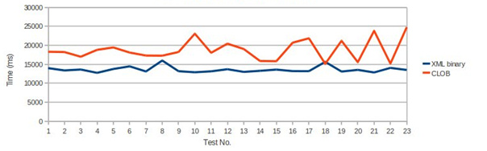
Figure 3: Sequential insertion of XML documents

This test showed significant and consistent difference in speed, favouring the XML binary storage type.

Test 2
Insertion of documents with an average size of 34 KB, autoCommit set to true, 10 threads, each inserting 10 documents in a row.

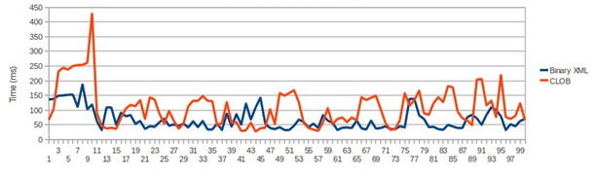
Figure 4: Parallel insertion of XML documents

The results of this test are in favour of binary XML storage.

Test 3
Random selects of one XML document each.

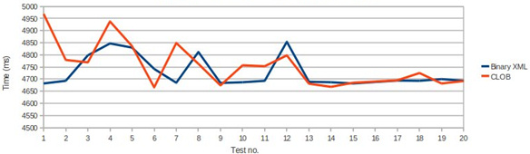
Figure 5: Random selection of documents

This test showed a slightly better average performance when using binary XML storage, although the speed of retrieval tends to become similar as time progresses.

Test 4
Random DML statements, 20 of them repeated in a row. The x-axis represents the queries and the y-axis the ratios of the numbers of CLOB to the number of binary XML in logarithmic scale.
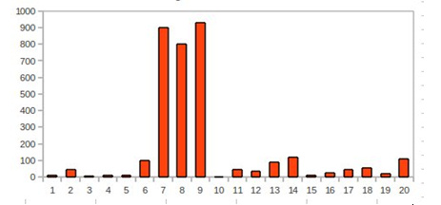
Figure 6: Random DML statements

The binary XML storage option outperforms CLOB in all queries with factor of 47 (or 21 if queries 7–9 are excluded).

Annex VI: Performance impact for future development

The following technical aspects affect significantly the performance of the PURE-XML system performance. Thorough investigation and analysis should be carried out before modifying any item listed below, as each is heavily optimized for performance:

- XMLType storage option (see Annex V: Performance Comparison of Storage Technologies)
- Java API caching implementation (see section 3.1)
- Data indexing for search (see section 2.1.4)
- URI and hierarchy retrieval (see section “Checkout and lock handling” under 2.1.2.1.3)
- Checkout process (see section “Checkout and lock handling” under 2.1.2.1.3)
- Distributed transactions (section “Distributed transaction management” under 2.1.2.1.3)

Annex VII: Activity Diagrams

Not all use cases are presented.

Create Node

Create folder activity diagram
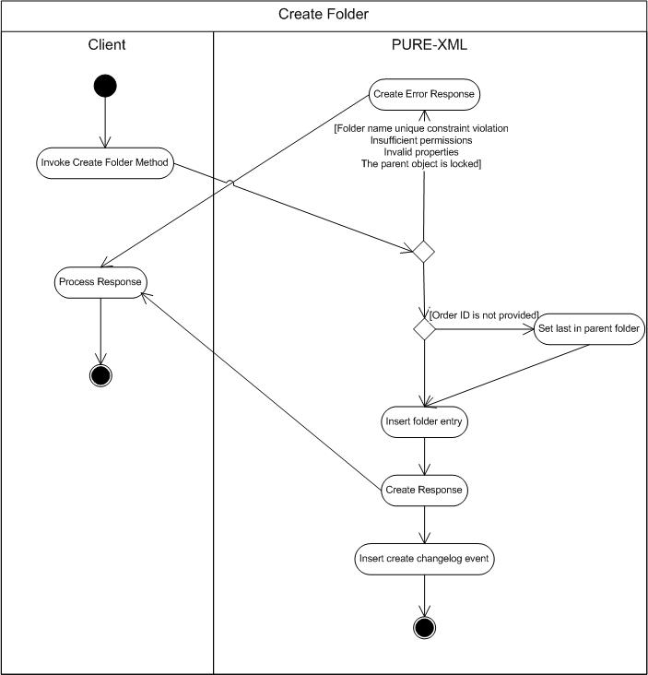

The diagram activities are continued through asynchronous process in 10.1.1.53 section.

Create Logical Unit activity diagram

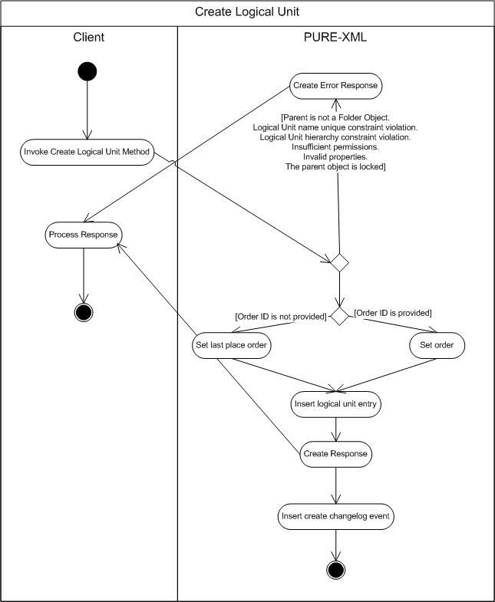

The diagram activities are continued through asynchronous process in 10.1.1.53 section.

Create File activity diagram

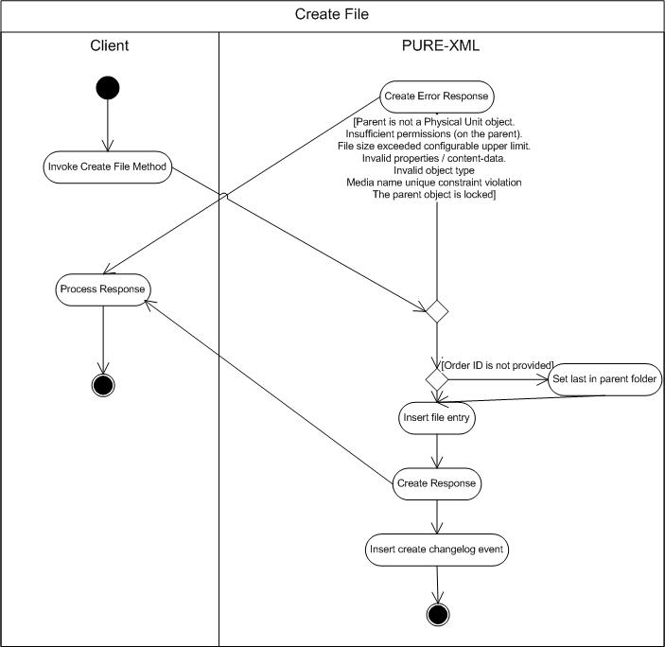

Create XML Rendition activity diagram

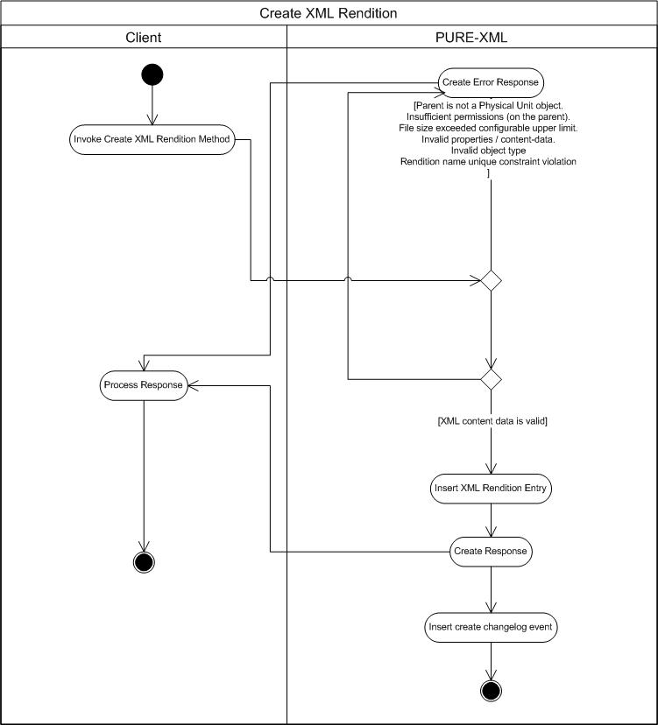

The diagram activities are continued through asynchronous process in 10.1.1.53 section.

Get Properties activity diagram

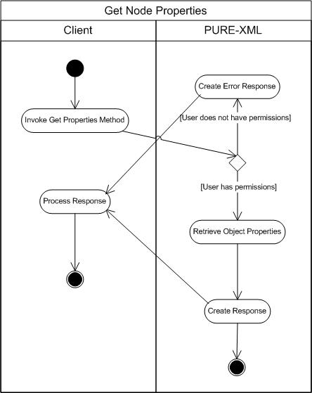

Get Content activity diagram

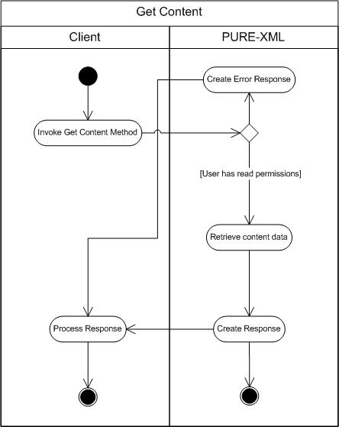

Update Content activity diagram

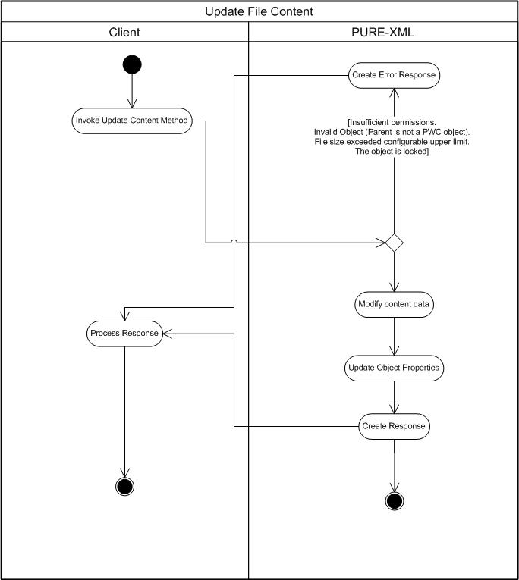

The diagram activities are continued through asynchronous process in 9.2.1.50 section.

Update XML Content activity diagram

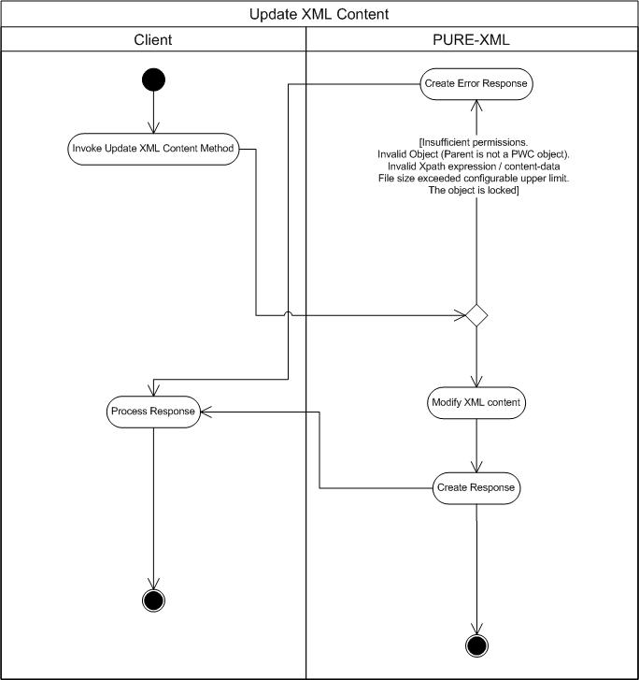

The diagram activities are continued through asynchronous process in 10.1.1.53 section.

Update Properties activity diagram

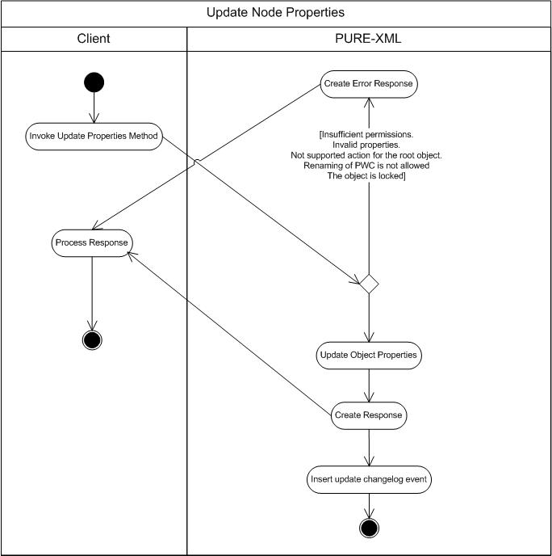

The diagram activities are continued through asynchronous process in 10.1.1.53 section.

Delete Folder activity diagram

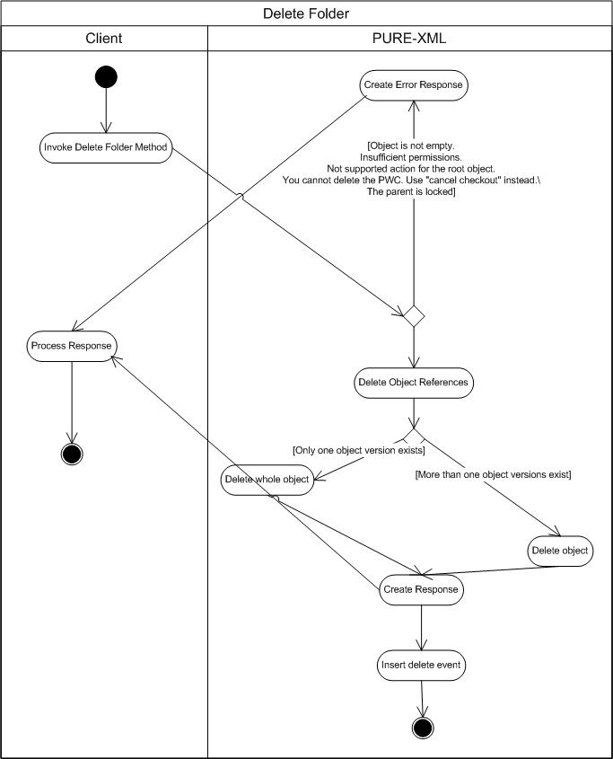

The diagram activities are continued through asynchronous process in 10.1.1.53 section.

Lock activity diagram
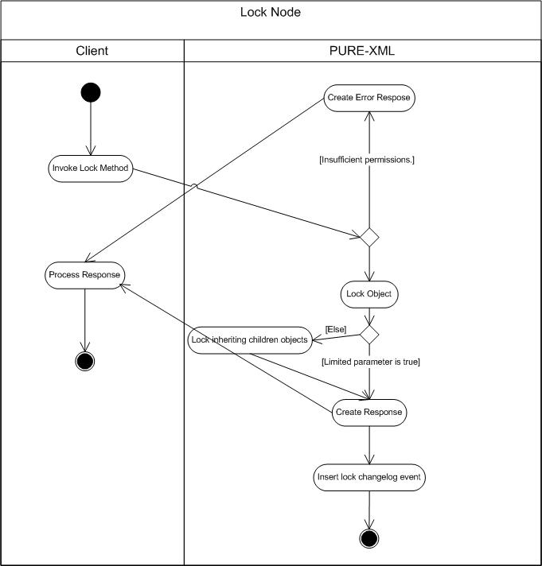

The diagram activities are continued through asynchronous process in 10.1.1.53 section.

Unlock activity diagram

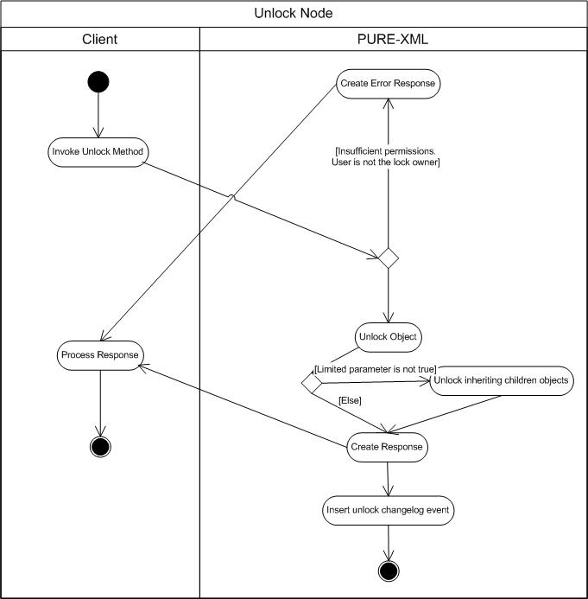

The diagram activities are continued through asynchronous process in 10.1.1.53 section.

Move folder activity diagram

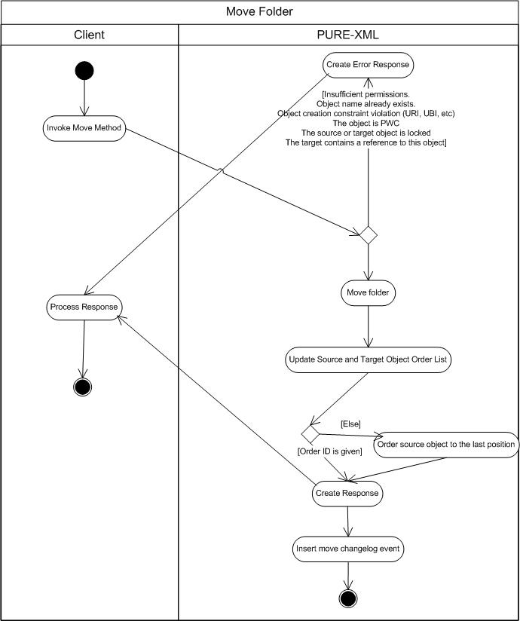

The diagram activities are continued through asynchronous process in 10.1.1.53 section.

Get Children activity diagram

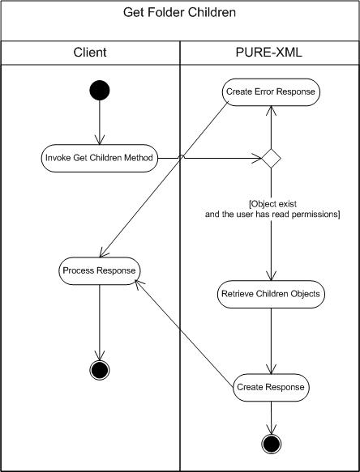

3.2.1.14 Define Content Type activity diagram
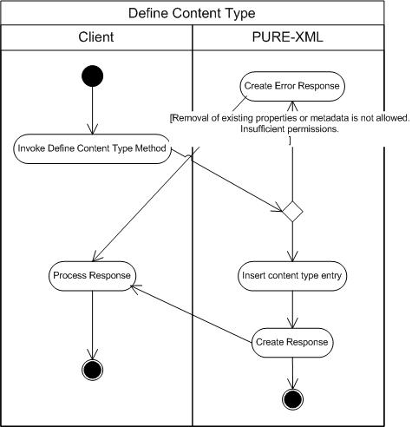

Undefine content type activity diagram

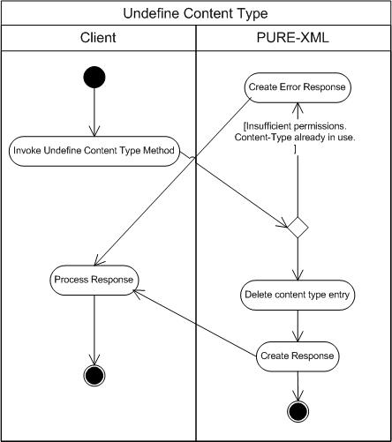

Get content type by name activity diagram

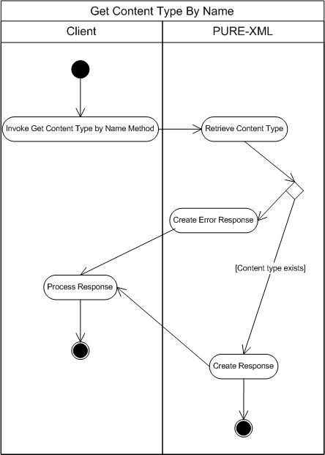

Get all content types activity diagram

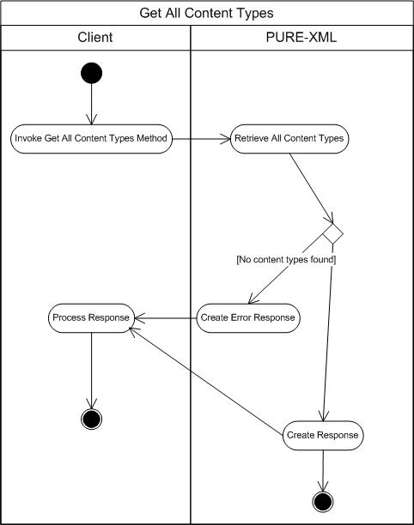

Get content type properties activity diagram

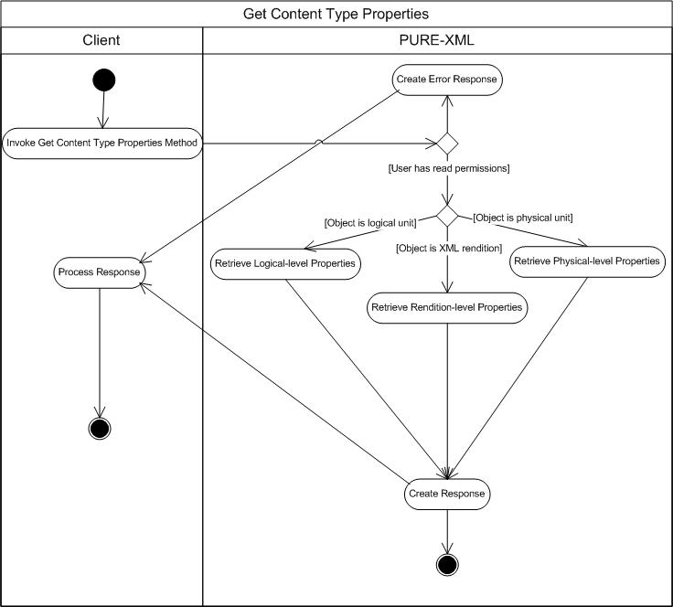

Set content type properties activity diagram

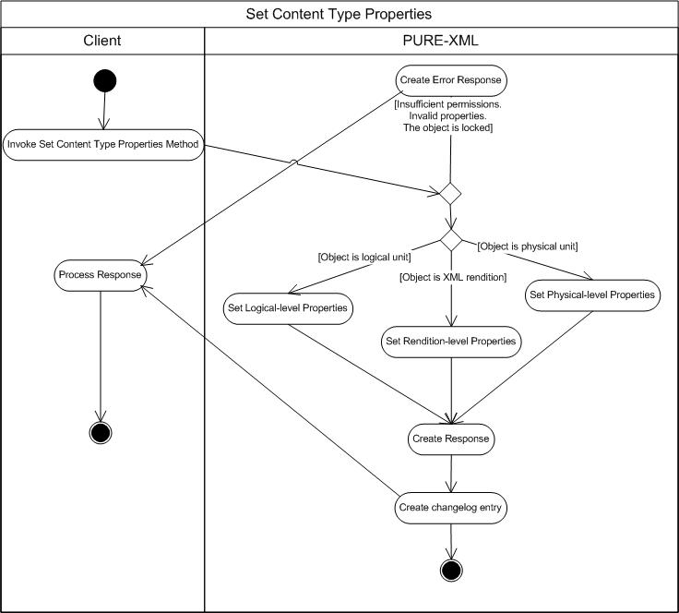

Get XML metadata activity diagram

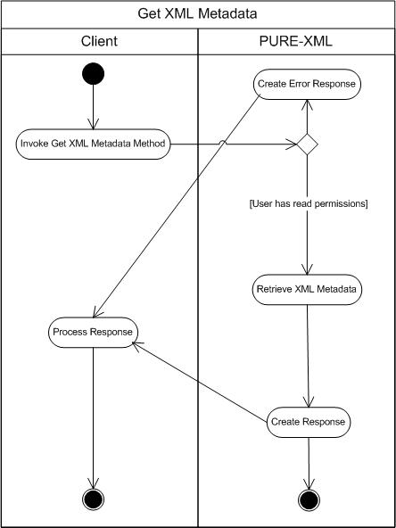

Get modifications history activity diagram

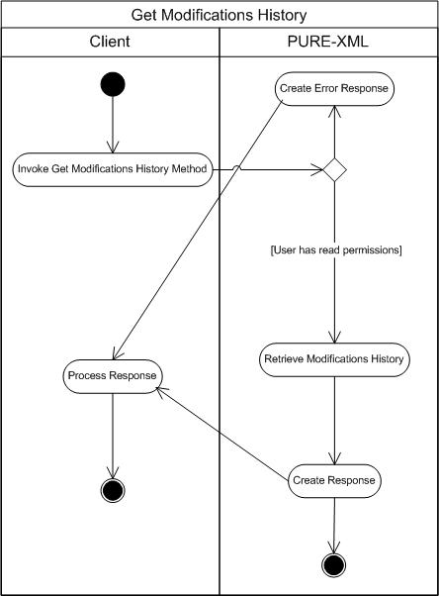

Changelog search activity diagram

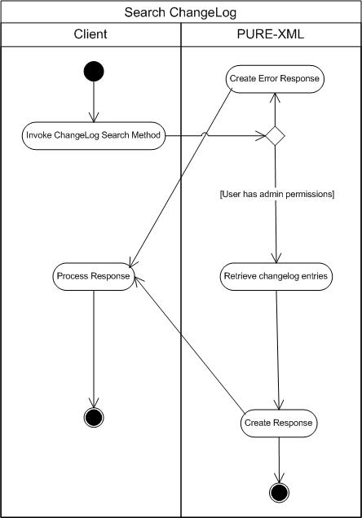

Changelog clean up activity diagram

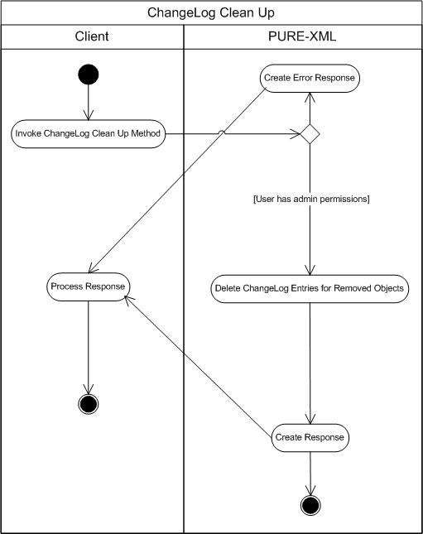

Get object ID activity diagram

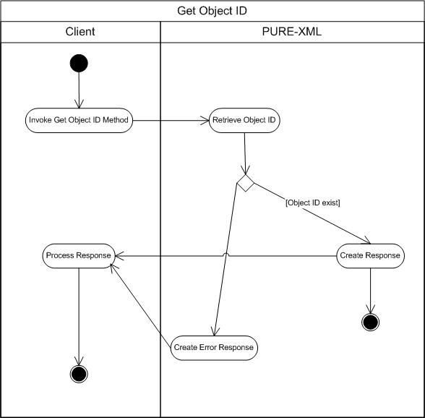

Get versions activity diagram

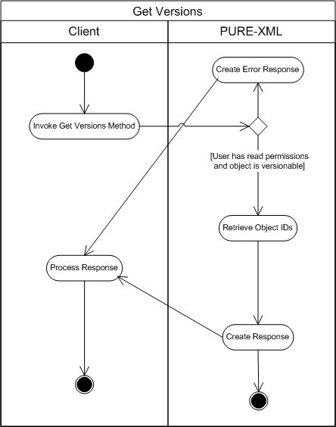

Get latest version activity diagram
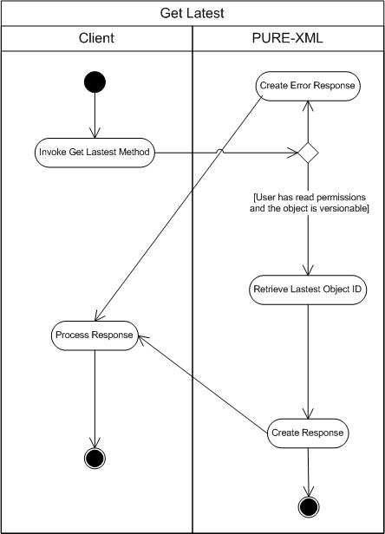

CheckOut activity diagram

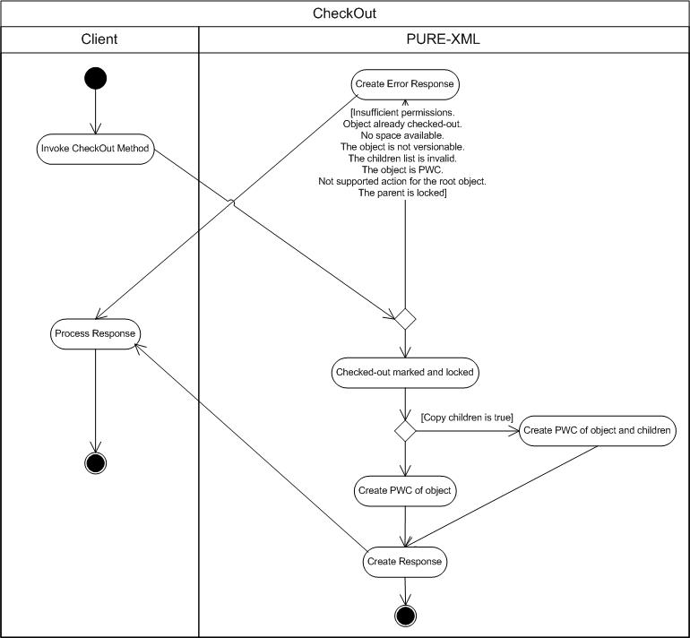

CheckIn activity diagram

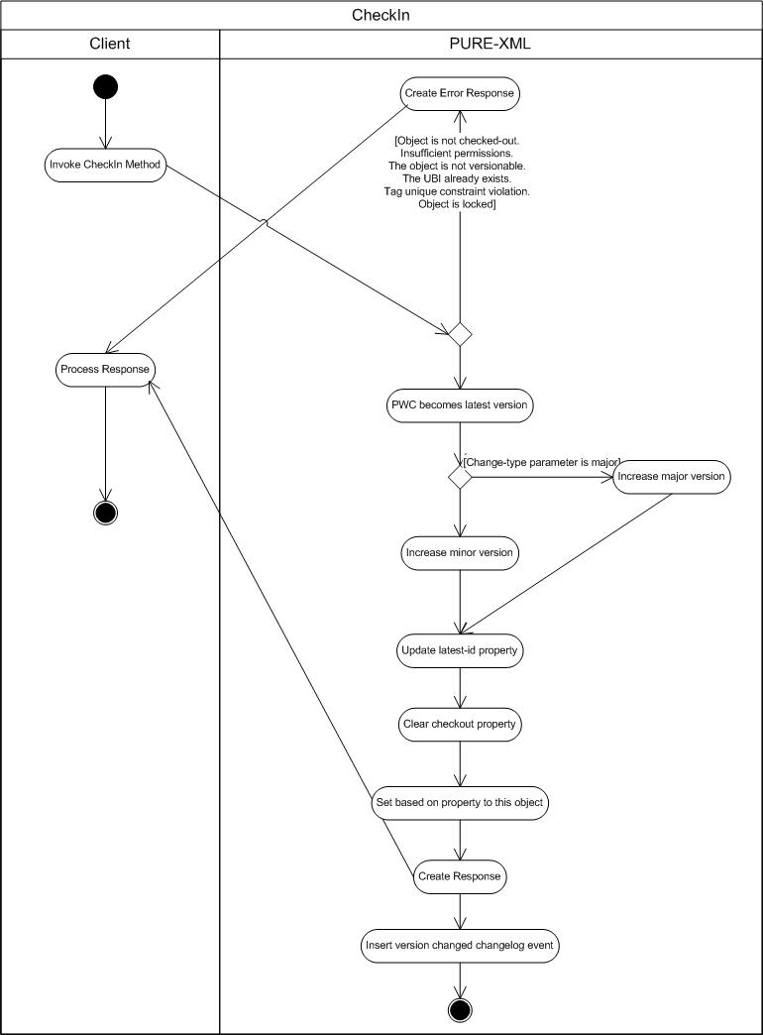

Cancel checkout activity diagram

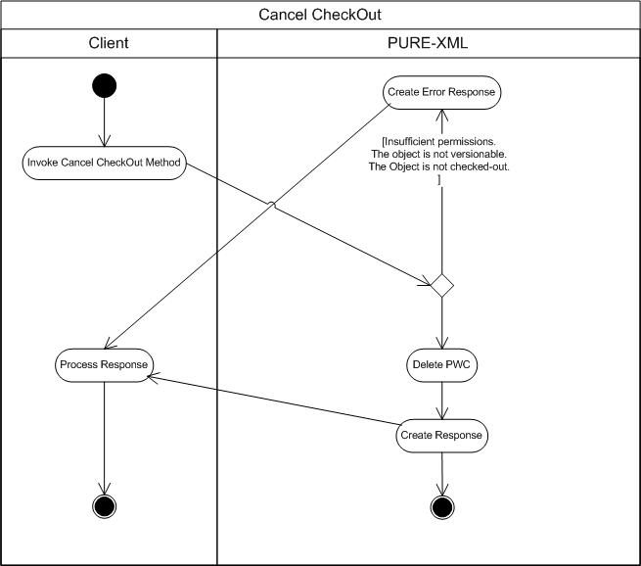

Define tag activity diagram

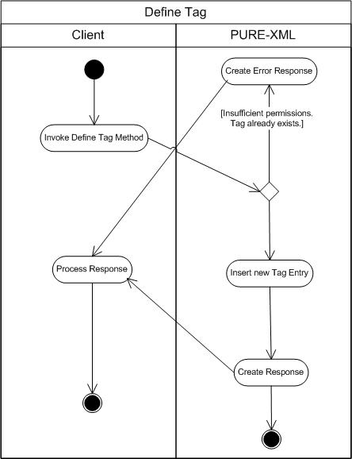

Undefine tag activity diagram

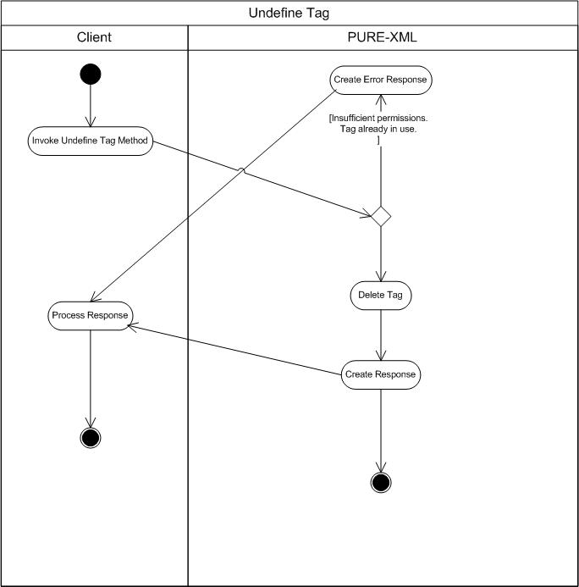
The diagram activities are continued through asynchronous process in 10.1.1.53 section.

Add tag activity diagram

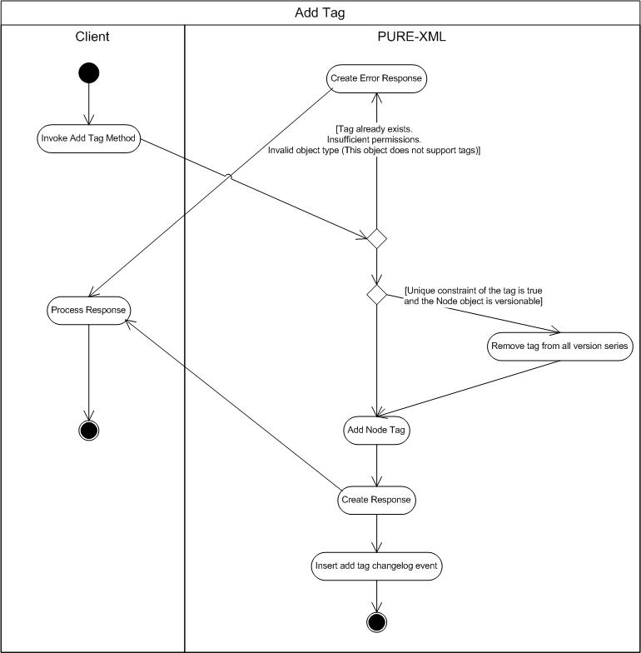

The diagram activities are continued through asynchronous process in 10.1.1.53 section.

Delete tag activity diagram

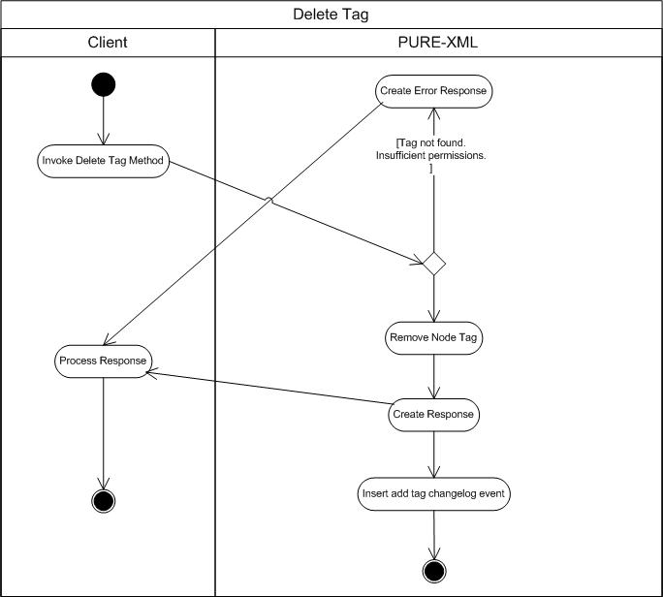

The diagram activities are continued through asynchronous process in 10.1.1.53 section.

Get tag by name activity diagram

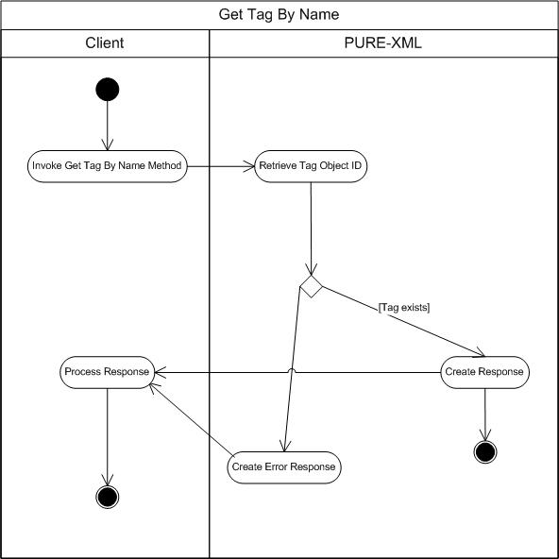

Get all tags activity diagram

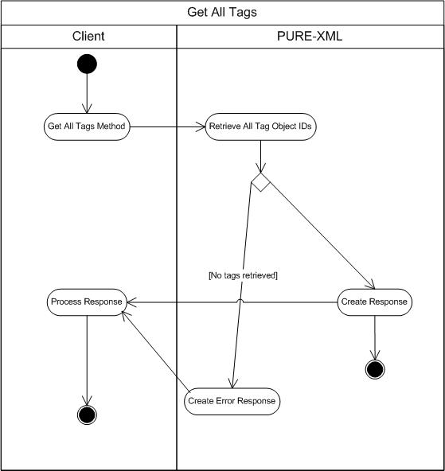

Define relationship activity diagram

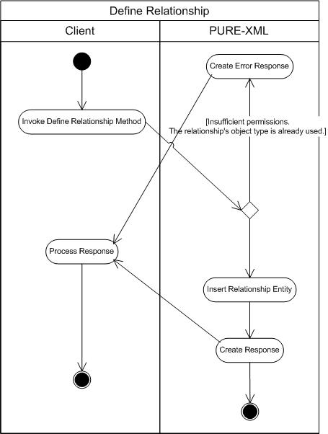

Undefine relationship activity diagram

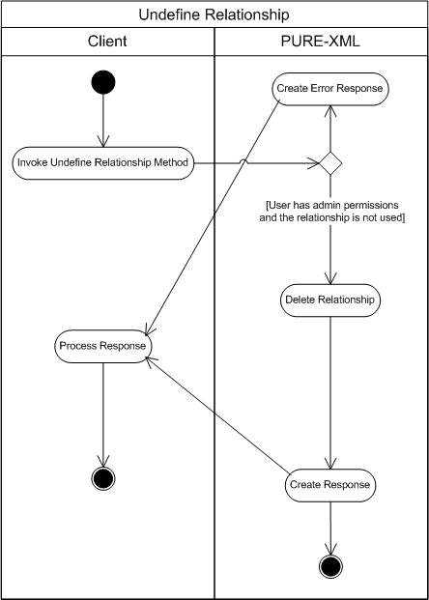

Get all relationships activity diagram

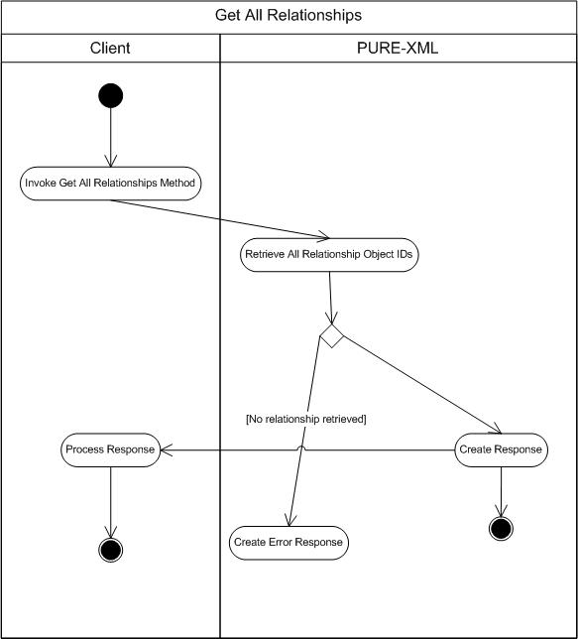

Get relationship by name activity diagram

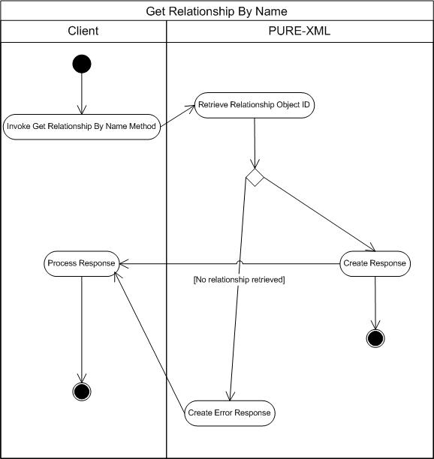

Create relationship activity diagram

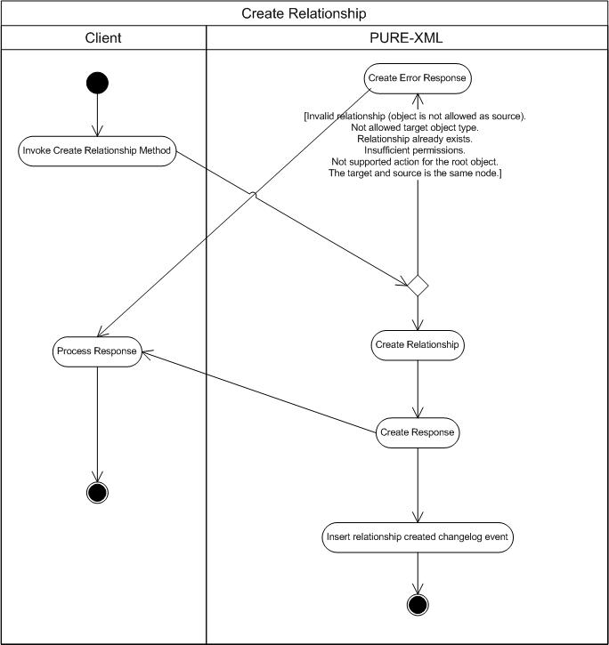

The diagram activities are continued through asynchronous process in 10.1.1.53 section.

Delete relationship activity diagram

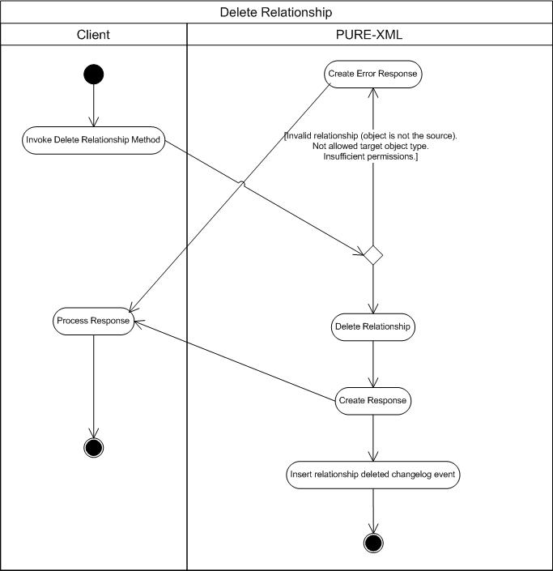

The diagram activities are continued through asynchronous process in 10.1.1.53 section.

Get related objects activity diagram

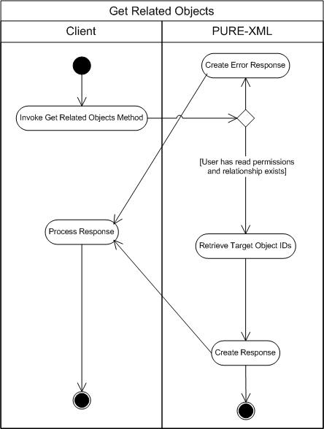

Get source relationships activity diagram

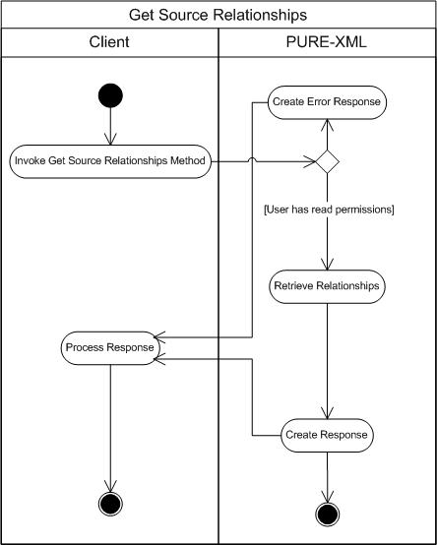

Get target relationships activity diagram

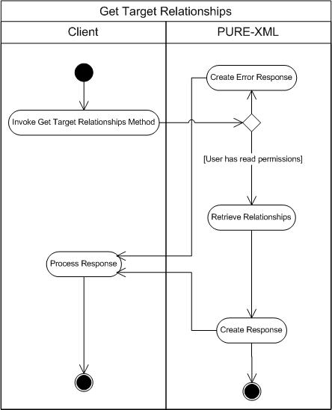

Define ACL group activity diagram

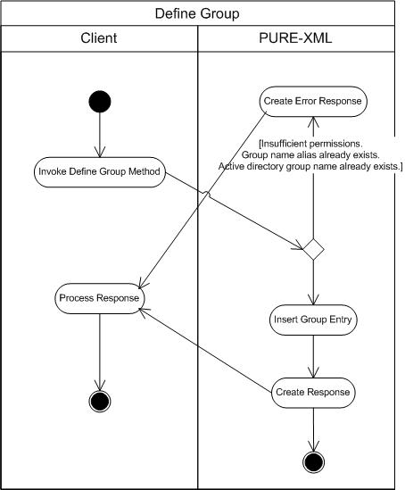

Undefine group activity diagram

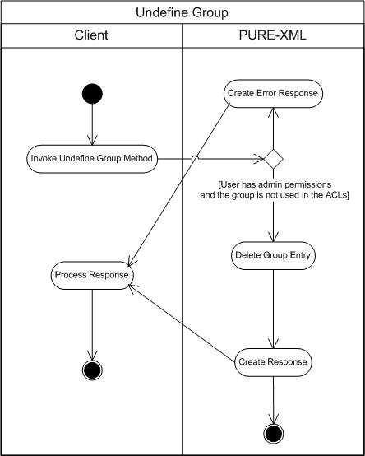

Get group by name activity diagram

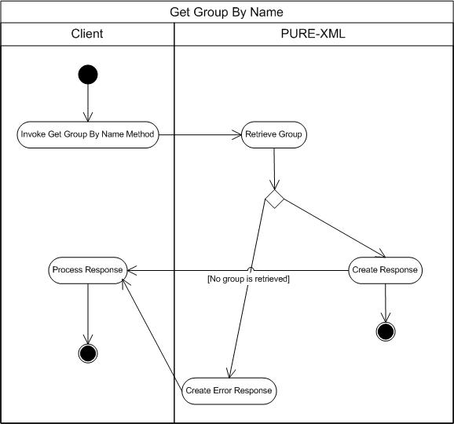

Get all groups activity diagram

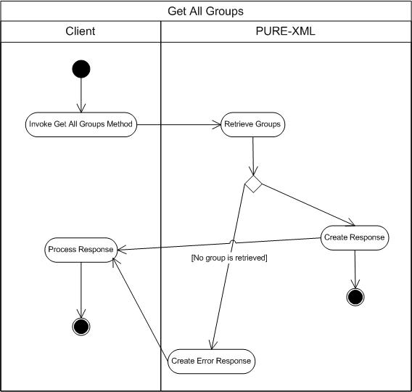

Get ACL activity diagram

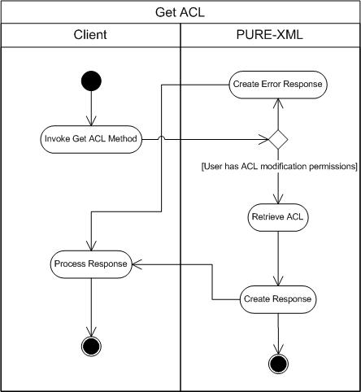

Set ACL activity diagram

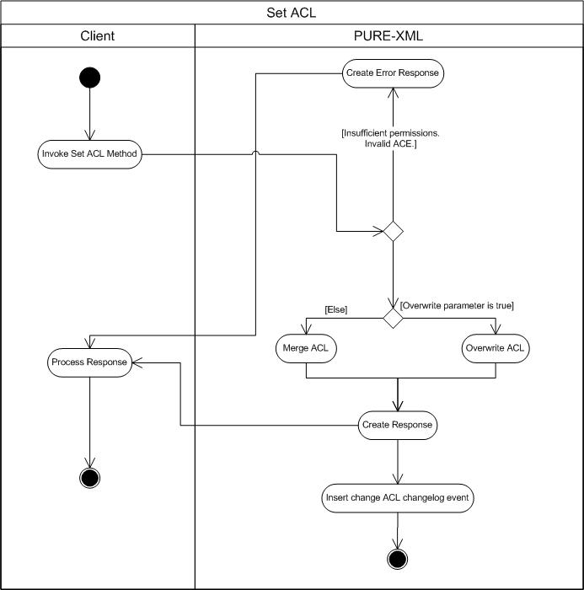

The diagram activities are continued through asynchronous process in 10.1.1.53 section.

Notifications activity diagram

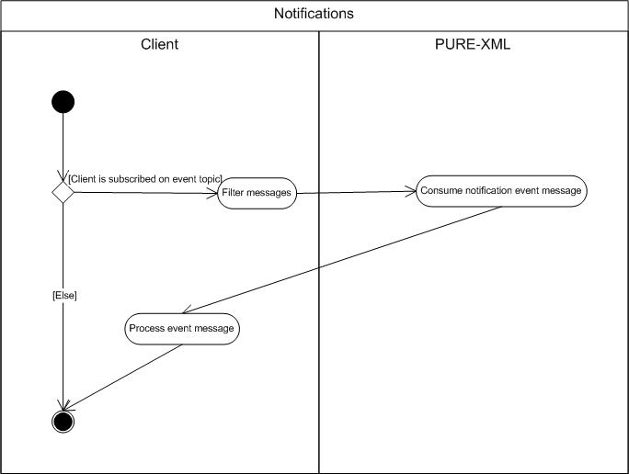

E: Examination, R: Responsible, I: Information, C: Contribution, A: Approval

